1.Please check whether the five xulrunner files (xulrunner29.0, xulrunner33.0, xulrunner45.0,xulrunner60.0_x86,xulrunner60.0_x64) and cefshaplib file exist in the Documents folder of your PC:
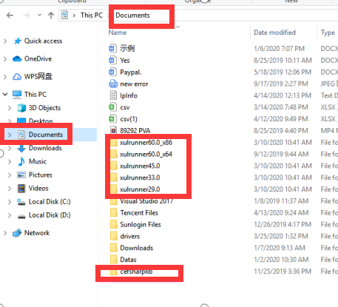
If not, you can download them from here:
http://www.botchief.com/xulrunner29.0.zip
http://www.botchief.com/xulrunner33.0.zip
http://www.botchief.com/xulrunner45.0.zip
http://www.botchief.com/xulrunner60.0_x86.zip
http://www.botchief.com/xulrunner60.0_x64.zip
http://developer.botchief.com/cefsharplib.zip
Unzip the downloaded files and put the unzipped folders into Documents. If the unzip tool of your system does not support unzip these files, you can download and install a 7-Zip tool to use.
Note that these folders cannot contain dual directories.For example, for files in the xulrunner60.0_x64 folder, their path should be C:\Users\Administrator(Or your own computer name)\Documents\xulrunner60.0_x64 instead of C:\Users\Administrator(Or your own computer name)\Documents\xulrunner60.0_x64\xulrunner60.0_x64.
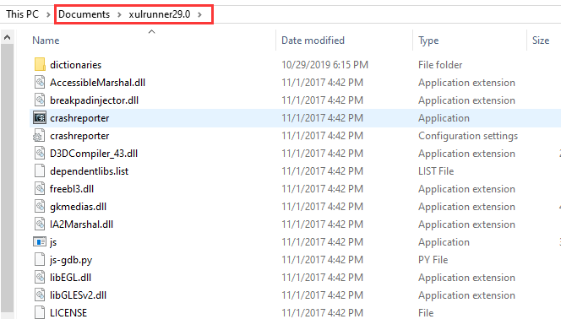

2.Install x86 and x64 versions of VC + + 2013 and VC + + 2015-2019:
VC++2013：
https://www.microsoft.com/en-us/download/details.aspx?id=40784
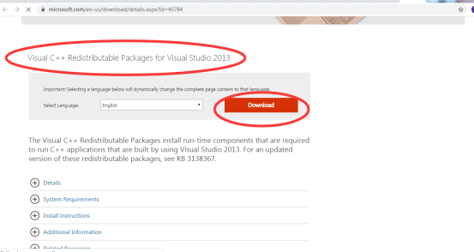
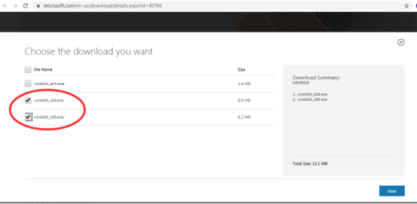
vc++2015-2019：
https://support.microsoft.com/en-us/help/2977003/the-latest-supported-visual-c-downloads
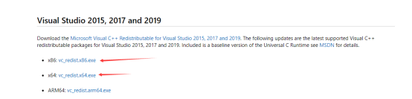
- Install. Net 4.6 if it is not installed on your PC or VPS:https://dotnet.microsoft.com/download/dotnet-framework
Then re-run PVA.

