Duplicate Sniper Introductions

1. Open the software Duplicate Sniper, fill in the email address and software serial number to enter the software, as shown in the figure below. 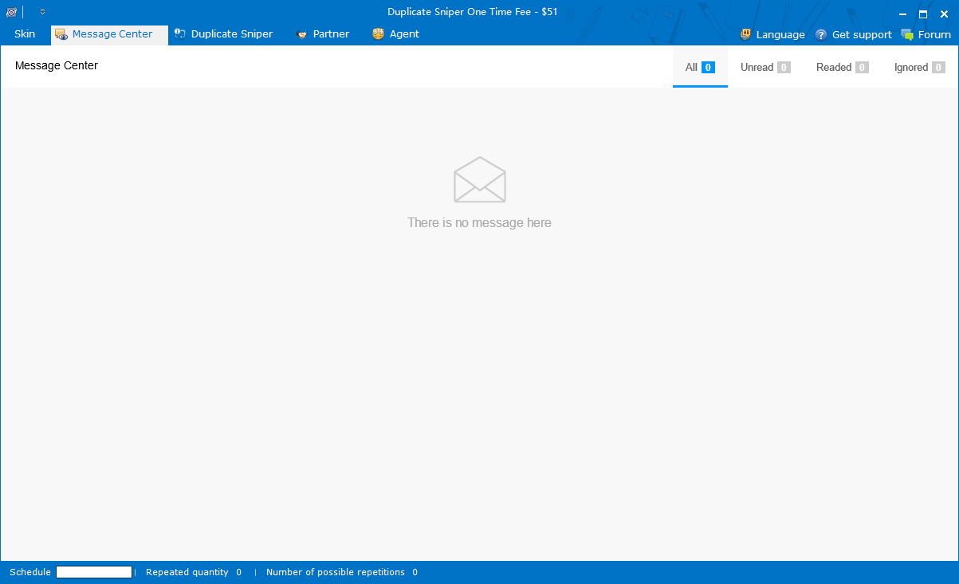
2. Click Duplicate Sniper to enter the page, as shown in the figure below.
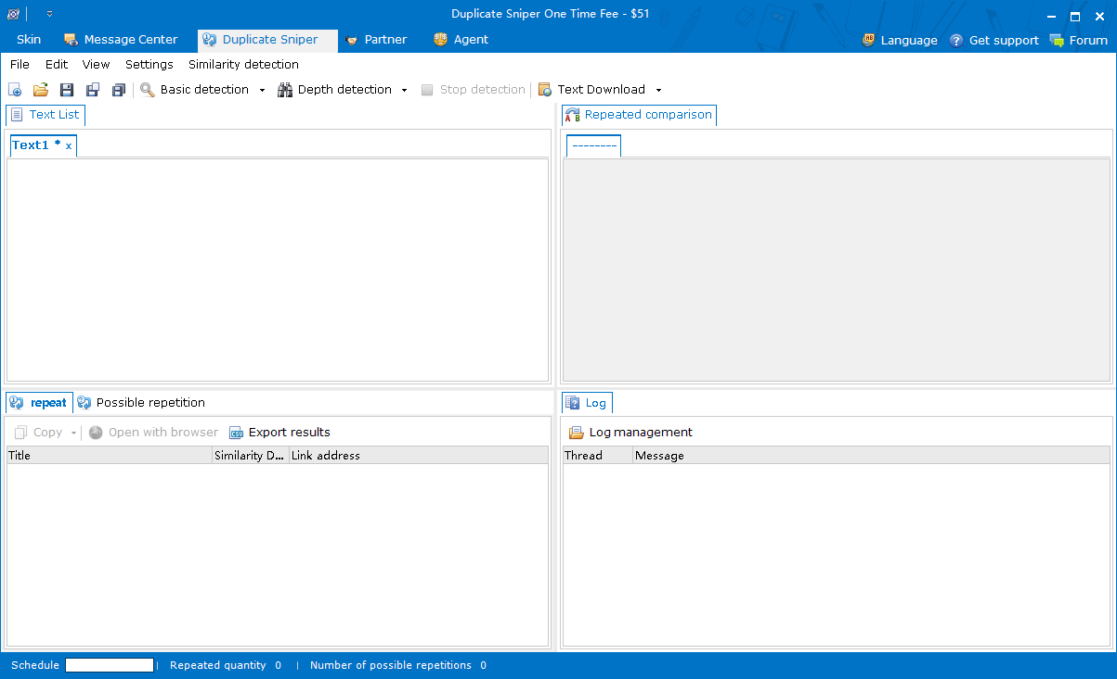
3. Duplicate Sniper Tutorial
(1) Basic Settings
Click “Basic settings” in “Settings”, as shown in the figure below. 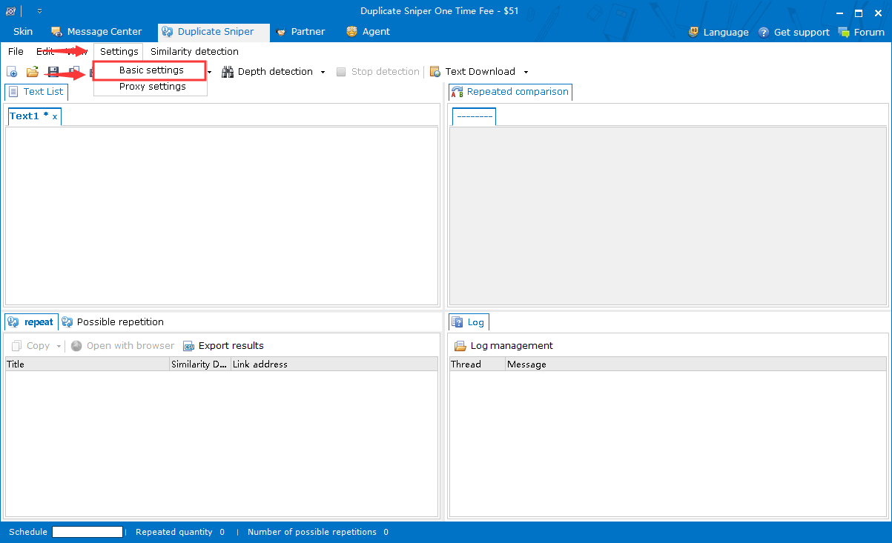After entering the basic setting interface, as shown in the figure below. 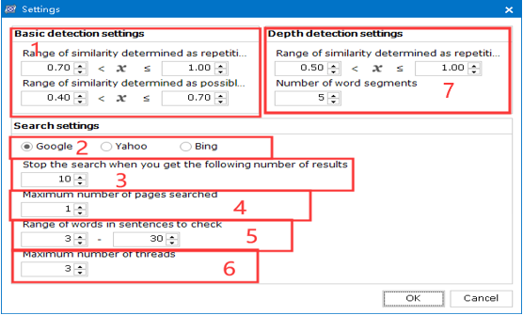
Area 1 above：Set the similarity range of possible repetition or repetition of basic detection.
Area 2 above：Select a search engine for searching text.
Area 3 above：Set the number of results to stop searching (when the total number of search results is the specified number, the software stops searching for texts).
Area 4 above：Set the number of pages of search results in the search engine.
Area 5 above：Set the word number range of the sentence to be detected in the basic detection (the system divides the text into several sentences by punctuation, and filters by the word number range of the sentence, and searches the filtered sentence).
Area 6 above：Set the number of threads (theoretically the more threads, the faster the search speed, but also the greater the computer performance requirements at the same time).
Area 7 above：Set the range of repetition similarity and the number of word segmentation in depth detection (in depth detection, the sentence search method is no longer used, but a more accurate word segmentation method is used to separate the keywords of the text through the number of segmentation and search).
(2) Proxy Settings
Click “Proxy settings” in “Settings”, as shown in the figure below. 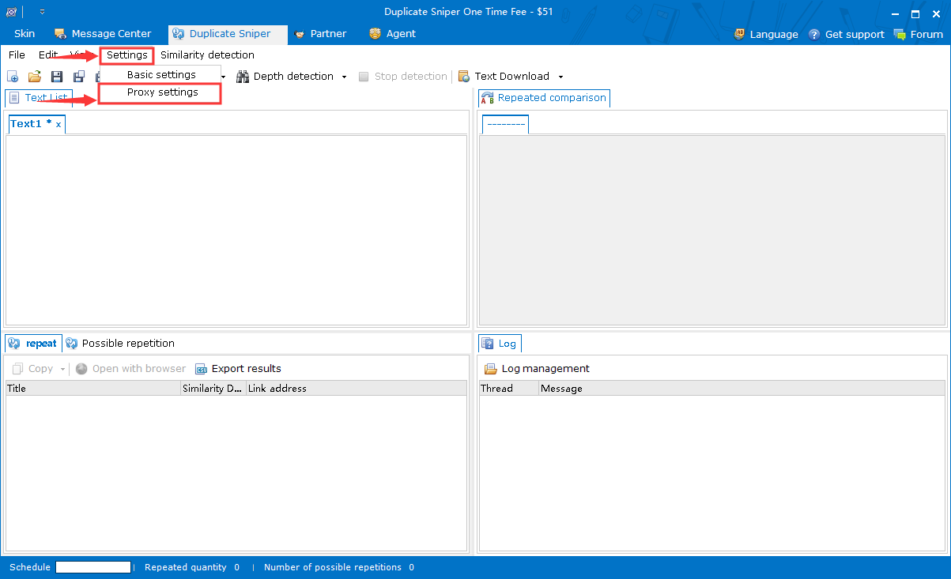After entering the proxy settings interface, as shown in the figure below. 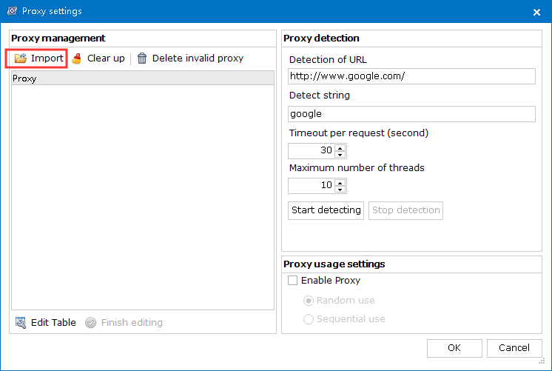Click “Import” in the figure above to import the proxy file ( txt format), as shown in the figure below. 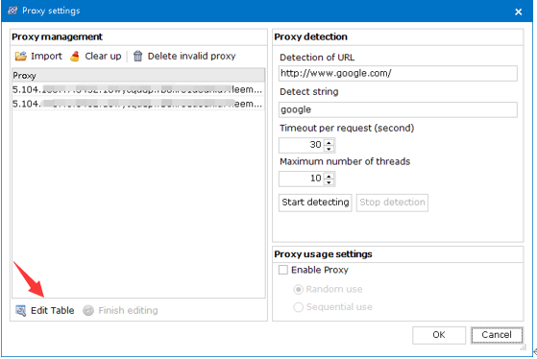Click “Edit Table” in the lower-left corner to edit the proxy, and you can add and modify the proxy. After finish editing, click “Finish editing” below to finish editing, as shown in the figure below. 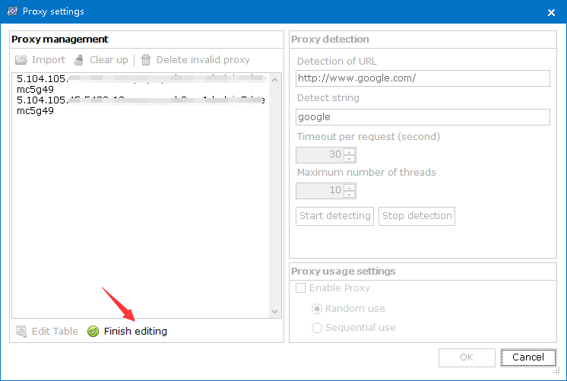After finish editing, you can enter the URL address, detection string, timeout and maximum threads amount of the detection engine on the right, as shown in the figure below. 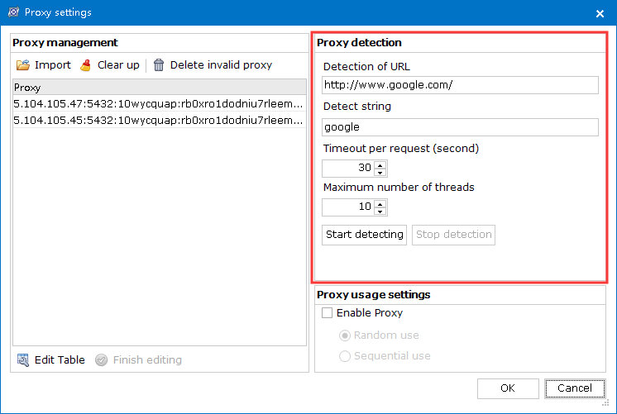Click “Start detecting” to check whether the proxy is available. After clicking, a progress bar will appear to display the progress. The left proxy file table will be divided into colors (red indicates that the proxy is not available, green indicates that the proxy is available, and yellow indicates that the proxy is being detected), as shown in the figure below. 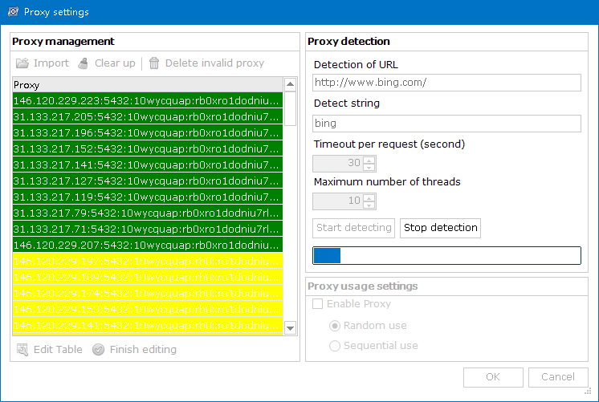After finishing the proxy detection, click “Delete invalid proxy” on the above to delete the invalid proxy lines. In the lower-right corner, you can set whether to use the proxy and select the proxy usage methods (random use and sequential use), as shown in the figure below. 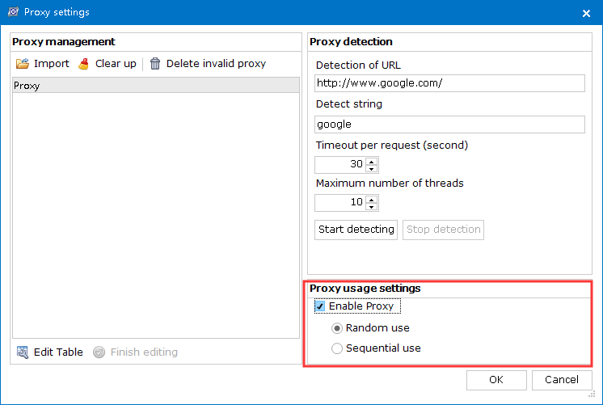Finally, click the "OK" button below to save. (3) Text similarity detection (basic detection, depth detection, batch basic detection, batch depth detection)
After setting related items, text detection can be carried out. Input the text to be detected (or import the text file in txt format) in the text box on the right. If it is a single text, click “Basic detection” or “Depth detection” to detect the text, as shown in the figure below. 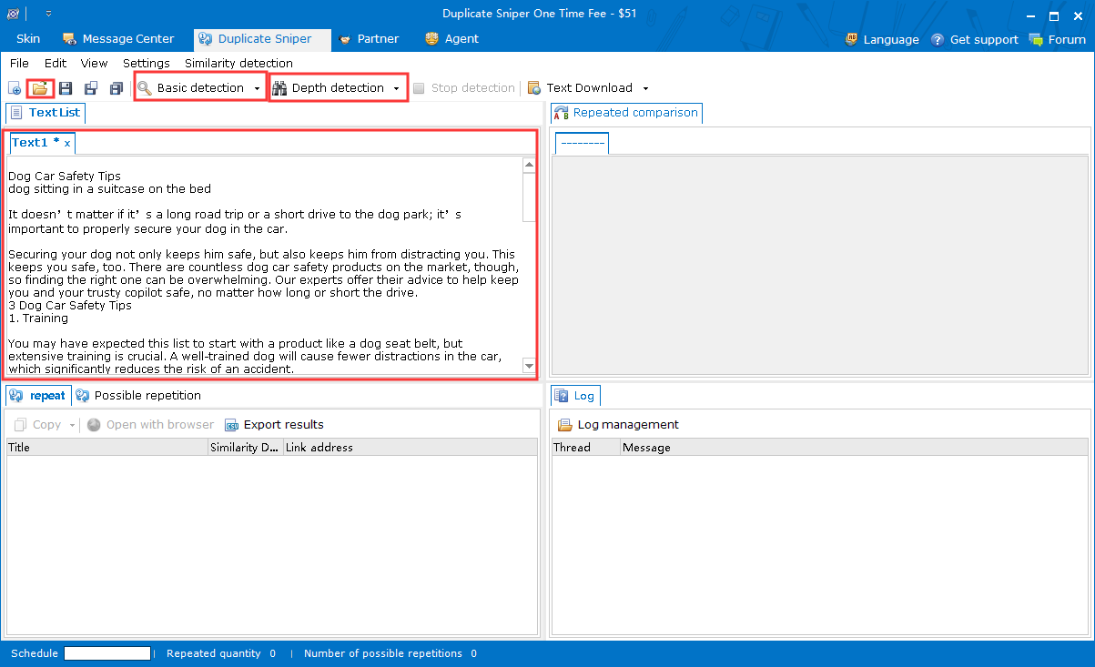The difference between the basic detection and the depth detection is that the basic detection is based on the sentence of the text, the detection time is fast but the detection result is less, the depth detection is based on the word of the text, the detection time is long but the detection result is more. Click “Basic detection” or “Depth detection”, the system will start to detect the text. The detection result and log will be displayed below. The progress bar will display the progress and the number of detection results, as shown in the figure below. 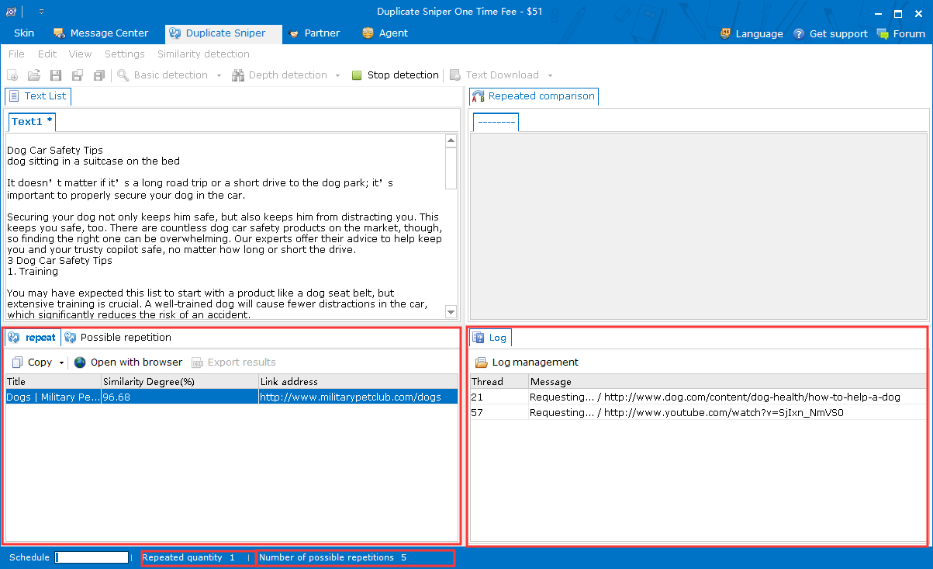In the repeated column (or possibly repeated column), the title, similarity, link address of the searched text will be displayed. Click the result line, the text box on the right will display the text and mark the same part in bold and blue font, as shown in the figure below. 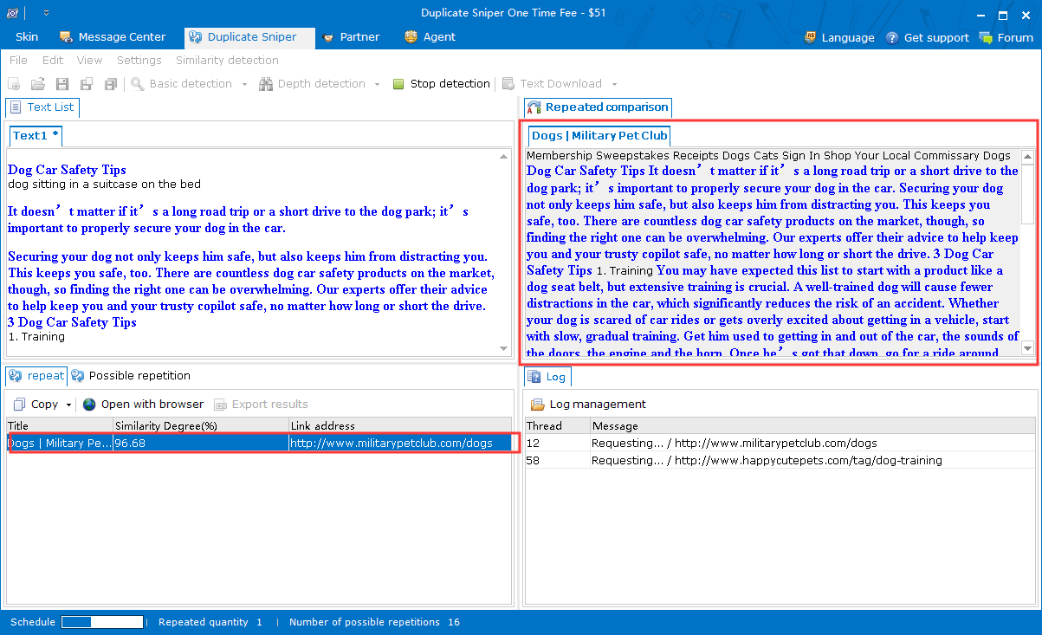Click “Log management” in the log column to view the search and detection log information of the day, as shown in the figure below. 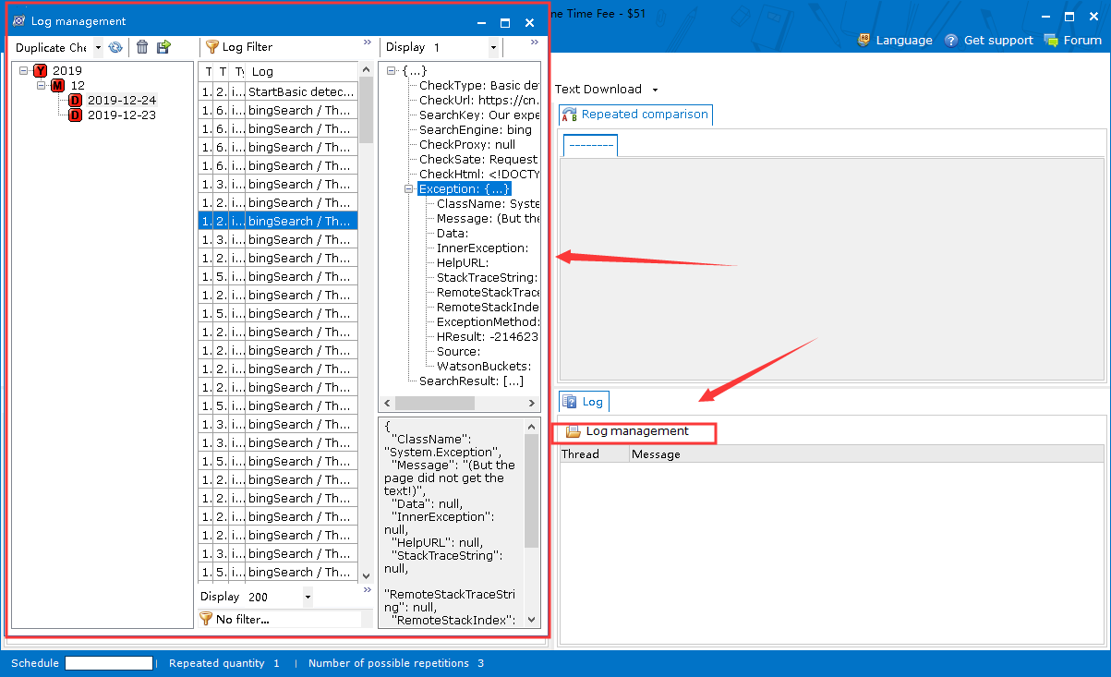When there are several texts to be detected, you can use batch basic detection (or batch depth detection) to detect the texts. Click “Batch basic detection” or “Batch depth detection”, as shown in the figure below. 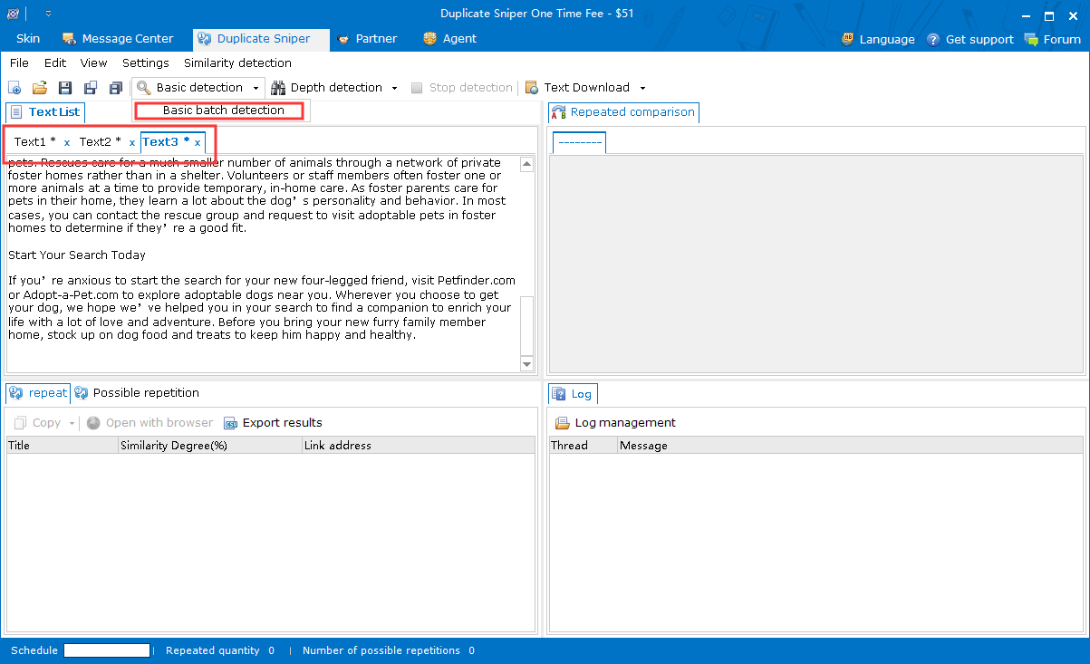After clicking batch basic detection (same as batch depth detection) to enter the text selection interface, select the text to be detected, and click “OK” to start the detection, as shown in the figure below. 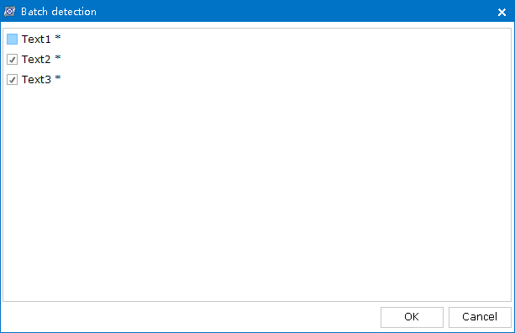Batch basic detection results are viewed in the same way as basic detection results.
(4) Text download and text bulk download
In the software, you can download the text through the URL link address. If the downloaded text is single, click the “Text Download” button to open the text download interface, enter the URL link address of the downloaded text, select whether to download to the current text box or the new text box and click “OK” to download, as shown in the figure below. 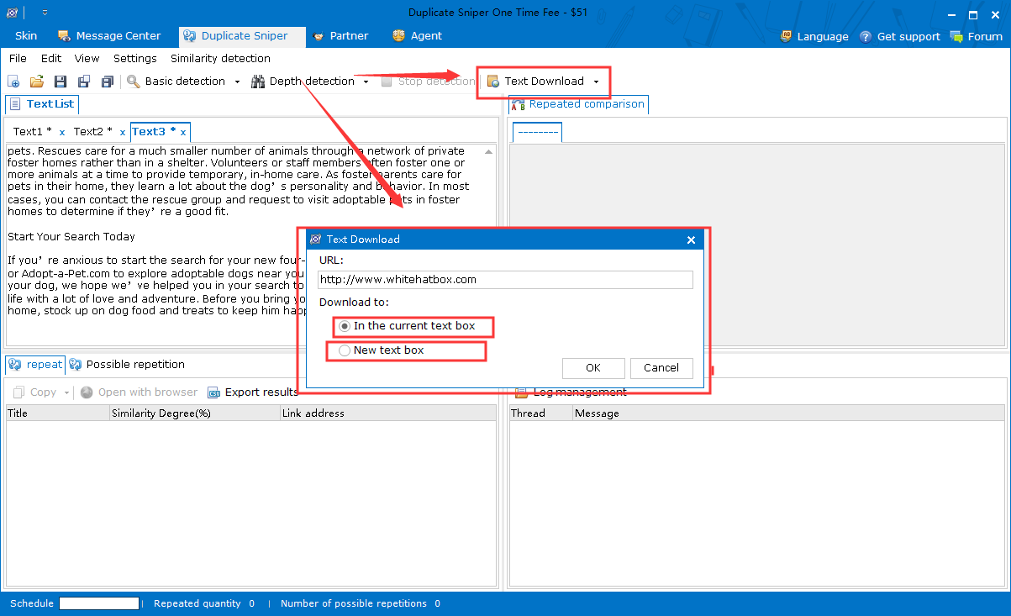After clicking OK, the text will be downloaded to the left text box, as shown in the figure below. 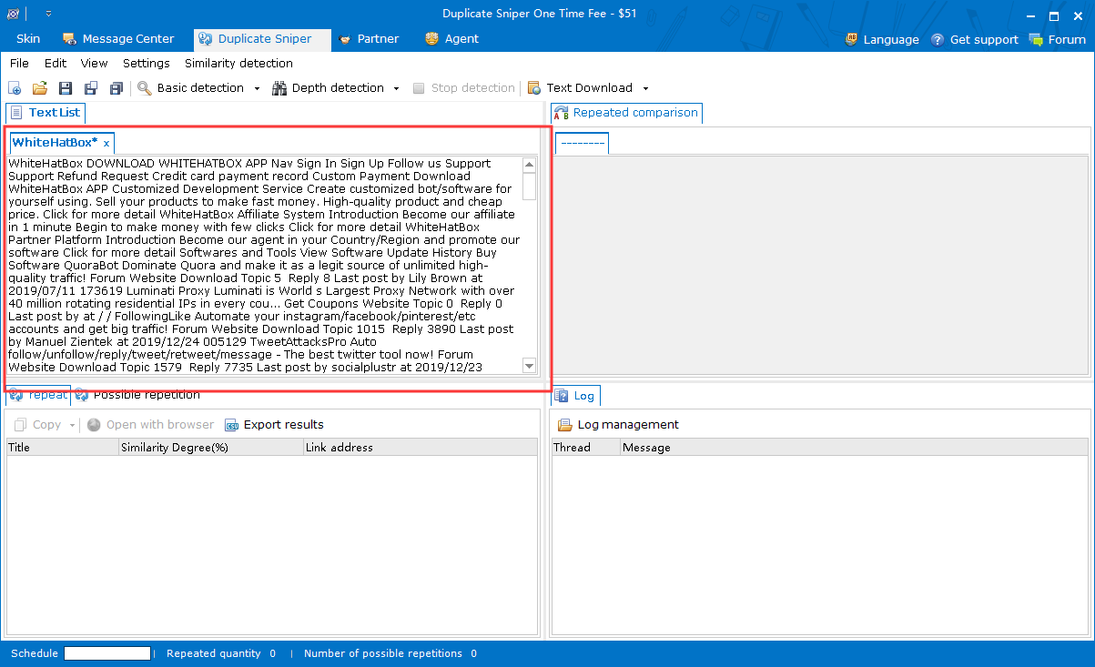If there are several downloaded texts, you can choose to download them in bulk, as shown in the figure below. 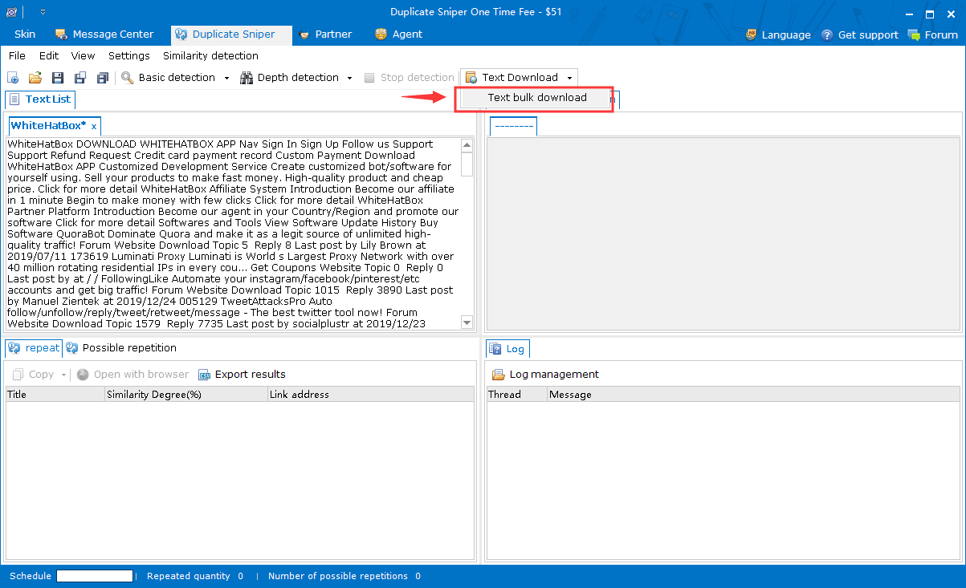Click “Text bulk download” to enter the bulk text download interface, and click “Edit Table” below to edit the URL in the table (the operation logic is the same as adding the proxy file), you can import the URL file (txt format) on the left side, then click “Start downloading” to download, as shown in the figure below. 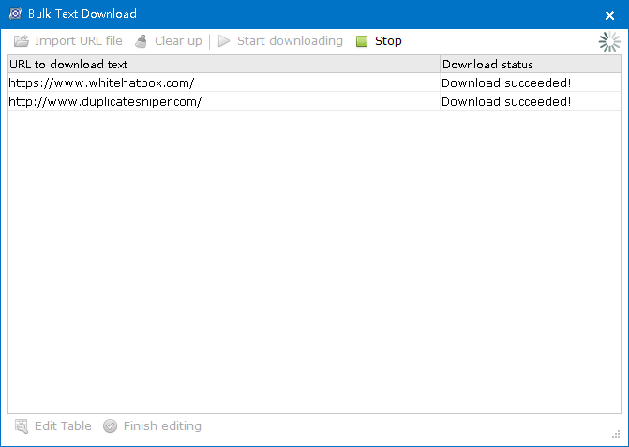After finishing downloading, the downloaded text will be placed in the text box on the left, as shown in the figure below. 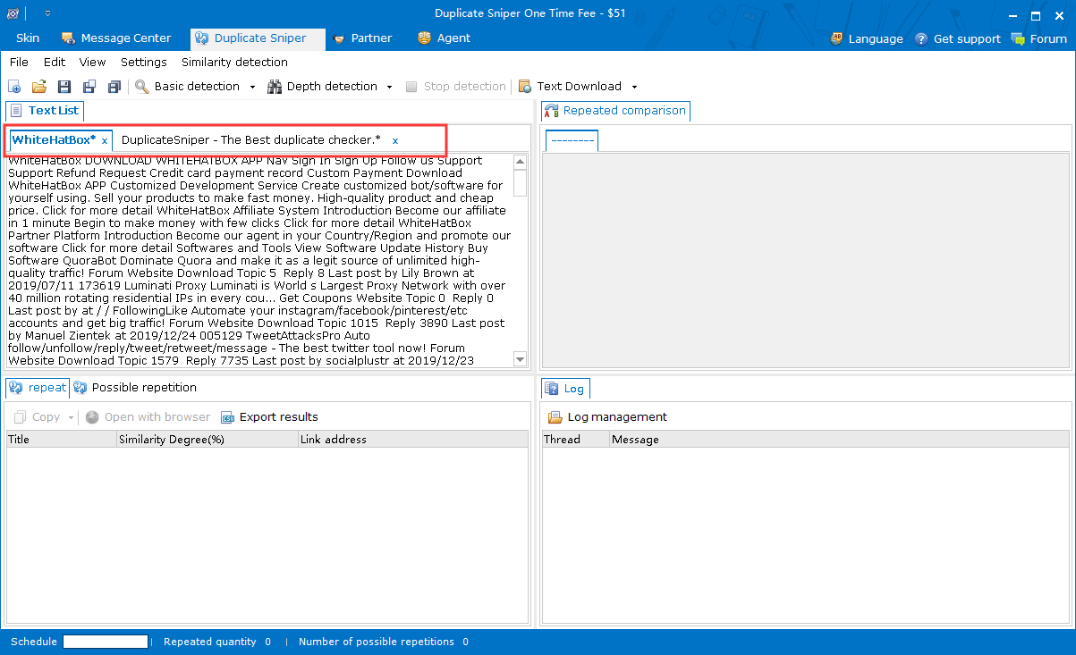(5) Text similarity detection
When there are two texts that need to be compared directly, the text similarity detection can be used to detect. Click the “Similarity detection” button to open the similarity detection interface, input the texts to be compared in the two text boxes, and click “Start detecting” to compare the texts, as shown in the figure below. 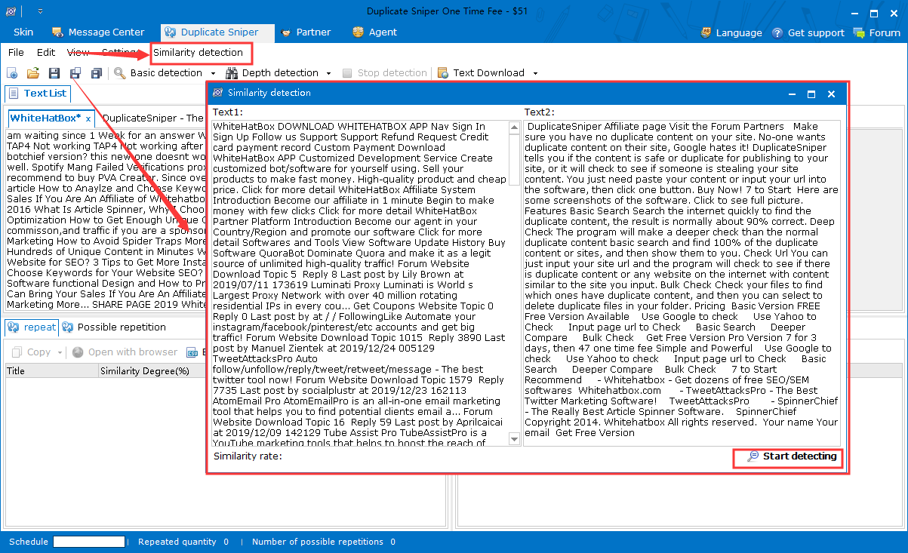After the detection, the same part of the text will be displayed in the text box, and the similarity will be displayed in the lower-left corner, as shown in the figure below. 