Manual for AppleID

Click this character “+” to create a task, then just name it:
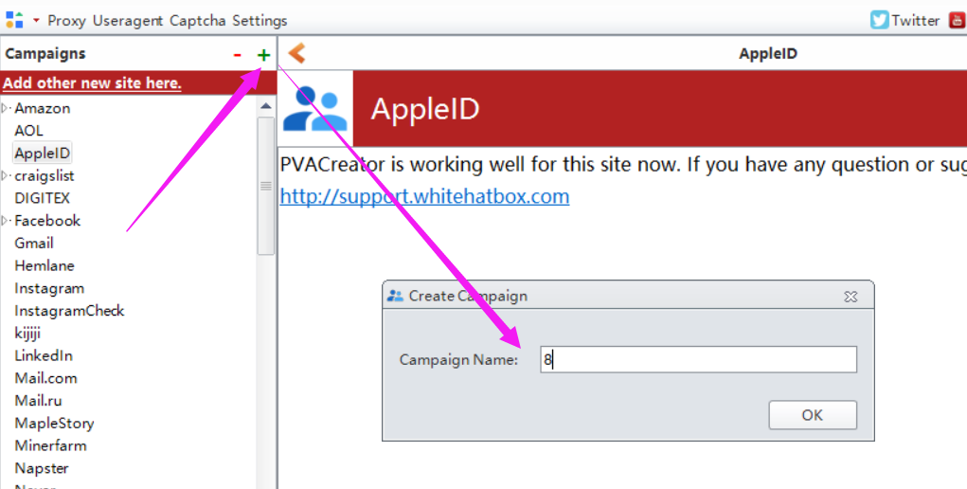

Following are the necessary variables needed to enter data before run：
- Email Information
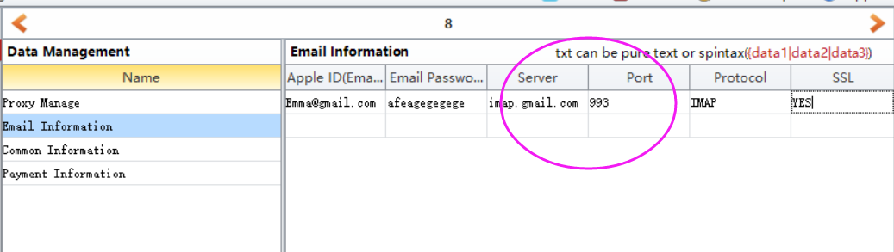
If you are using other domains to register account, and if you do not know where to find the server information, you can Google it, or follow this manual to check if you can find the related information. I will send it this file to you attached with this manual.

2, Common Information
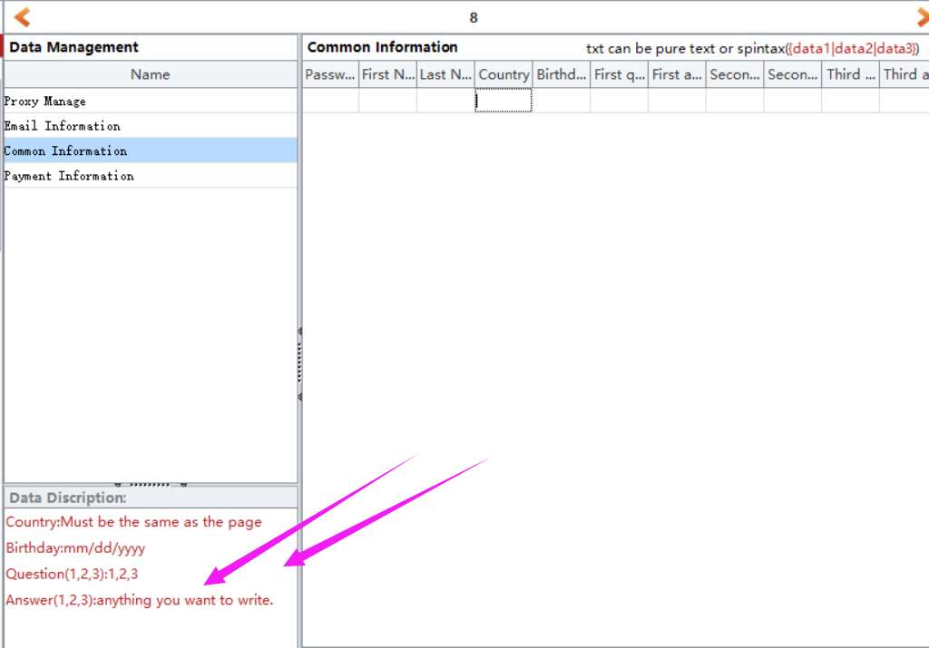
Check this one to know how to enter data for them.

3, Payment Information
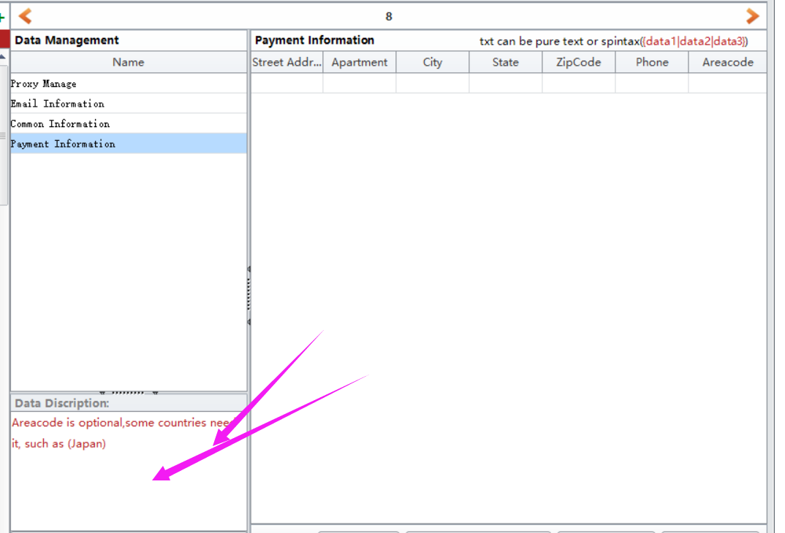
You must enter data for all fields except Areacode. Areacode is necessary only for some countries, eg: Japan

4, Save
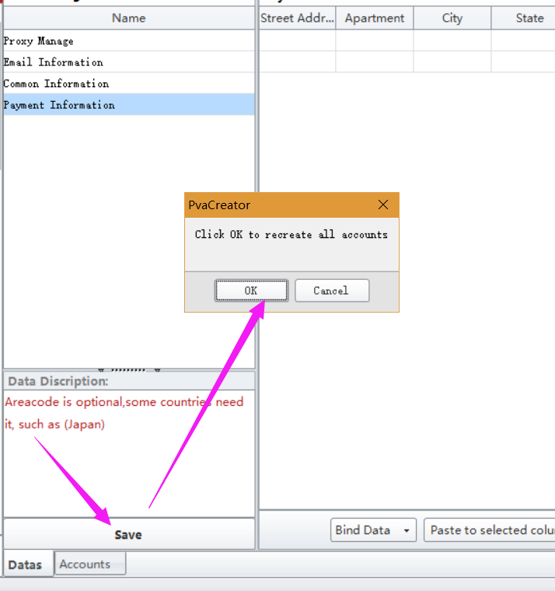
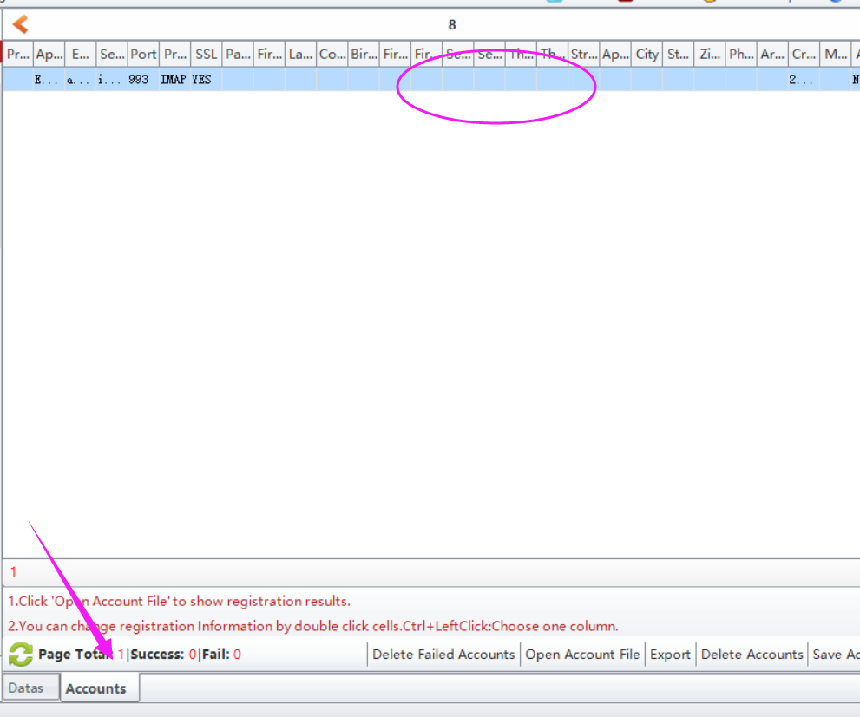

5, click Start button to start to run.
When it starts to run, here will be a debug window open, and you can view the whole running process.
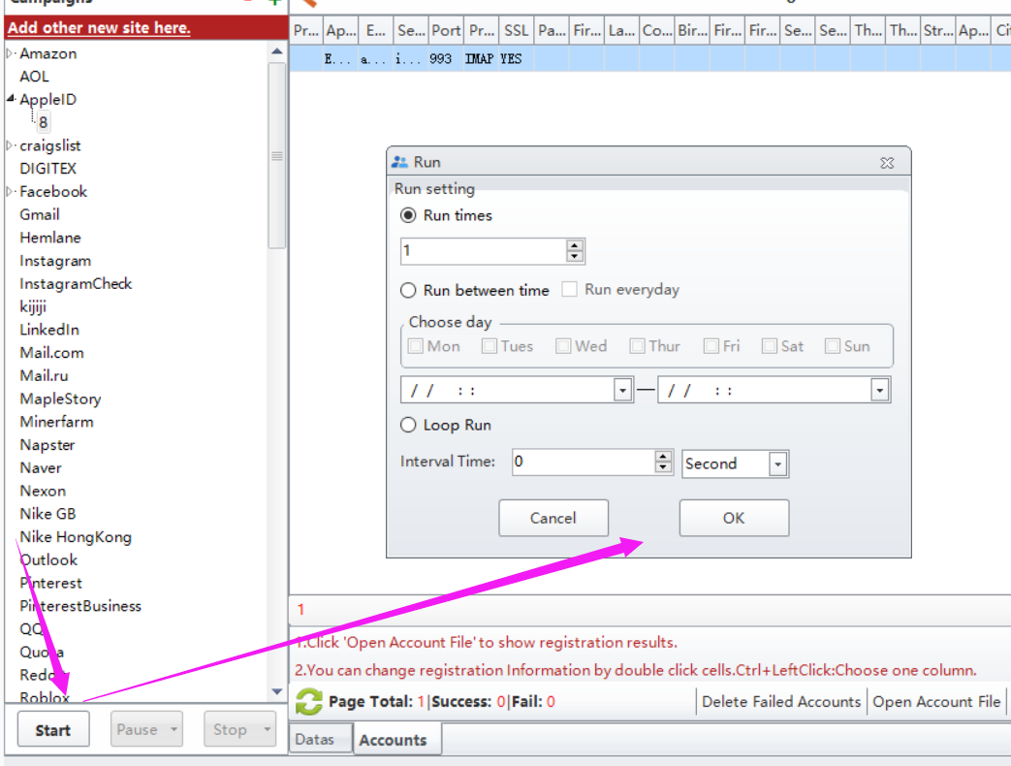

Options under “Bind Data”:
Import from file: import the data from your local prepared file at a time. Note: please choose the column first where you need to upload the data to.
UseRandom: custom some letters, numbers to auto generate data for these information. Such as full name, age, password. Note: please choose the column first where you need to custom and auto generate data.
Eg: if the first character is Funny, i will auto generate 1-4 number behind it. The first picture is the settings, the second one is the result it generates.
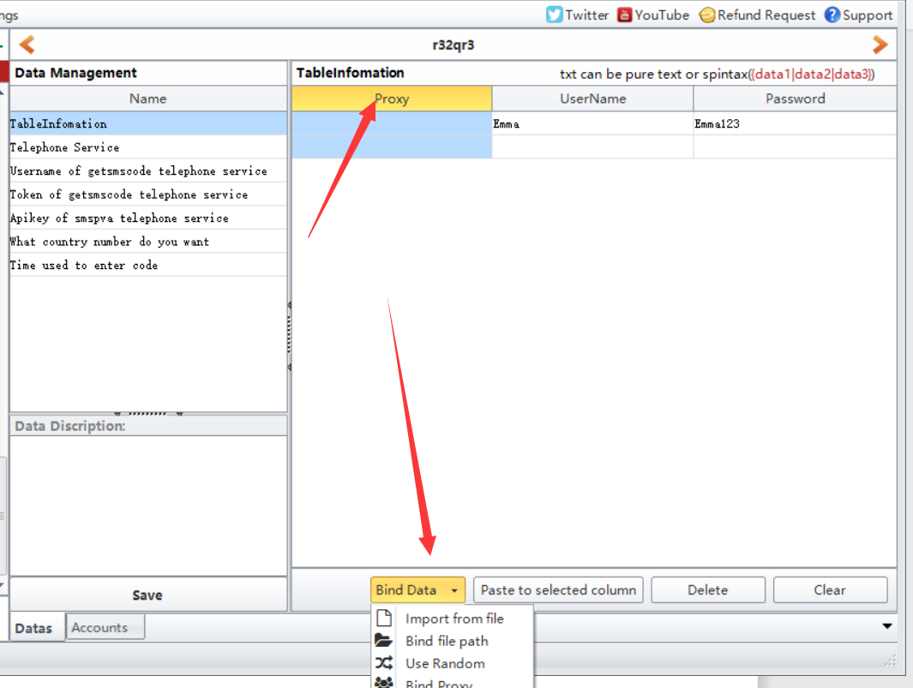
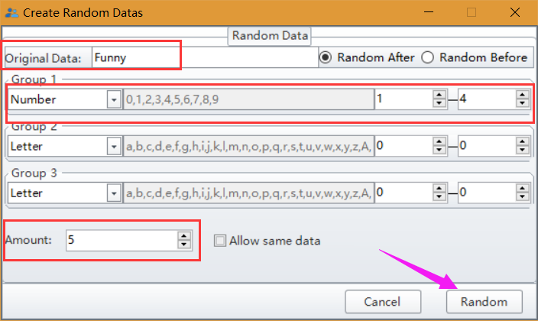
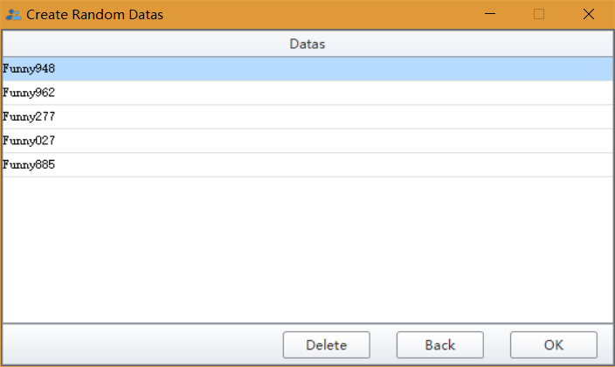
Bind Proxy/Useragent: bind proxy/useragents to these data at a time.

