Click this character “+” to add a task first:
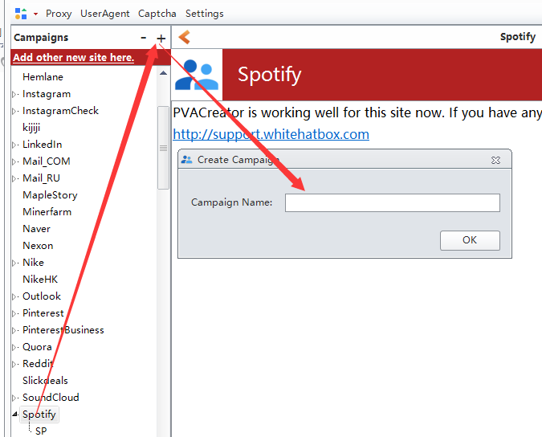

1. In “ EmailInforamtion” option, enter these value for them.
Username: your email address
Email-Password: your email account password
Protocol:your email protocol
Server: your email server
Port: your email server port
SSL: your email server ssl. Usually please enter YES
Eg: my email address is lhpchar@gmail.com you can search Gmail server settings online.
Server: imap.gmail.com
Port: 993
SSL: YES
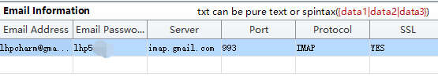Here are steps about how to find these settings:
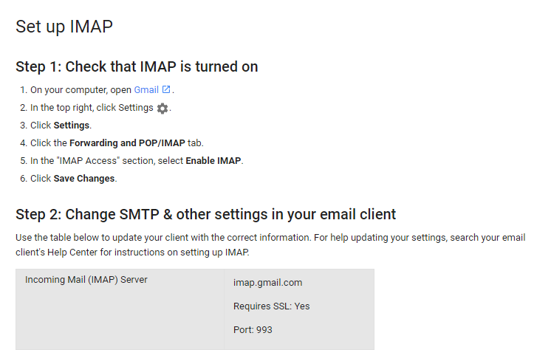

- Common Information:
You can leave them empty , then the program will random one. Or you can fill them by yourself.
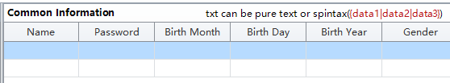

- 2Captcha ApiKey:
Register an account at 2captch.com, then charge the account, find your api key in your account details and fill it to the variable:
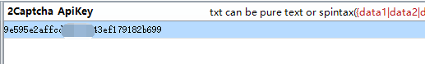

- Proxy Manage:
Input your http proxies here, one proxy per line. This one is optional, you can leave this one to be empty.But we recommend you to use it if you need to create multiple accounts:
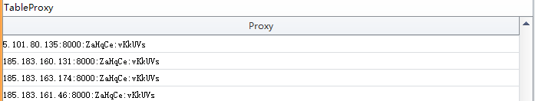

5.Leave it empty.
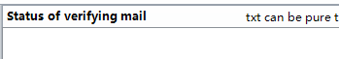
After you finished all these variables, then click Create Accounts button first, then click Start to register accounts.
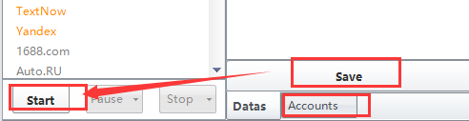
You can check the details in Account module:
