PVA Gmail tutorial
You must to fill these variables, you can leave others empty:
- Usernames: Fill in by yourself, the format like this:
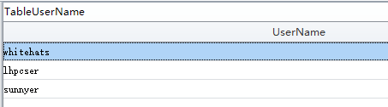
- TablePhoneService: we recommend you use getsmscode service, so you can fill 2.
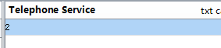
3.Please check point 7
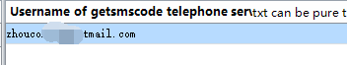
4.Please check point 7
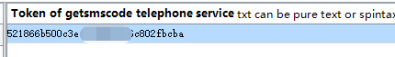
5.The program provided multiple phone countries, choose one by yourself:
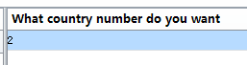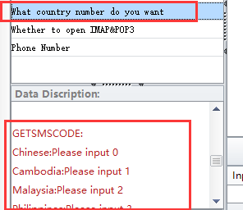
6.Just fill 0
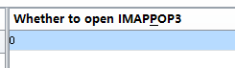
Point 7. How to use getsmscode service?
- Register an account at getsmscode.com, then charge for the account
- Then go to User Center, click Project List, The first line is Google, so just Favorite it.
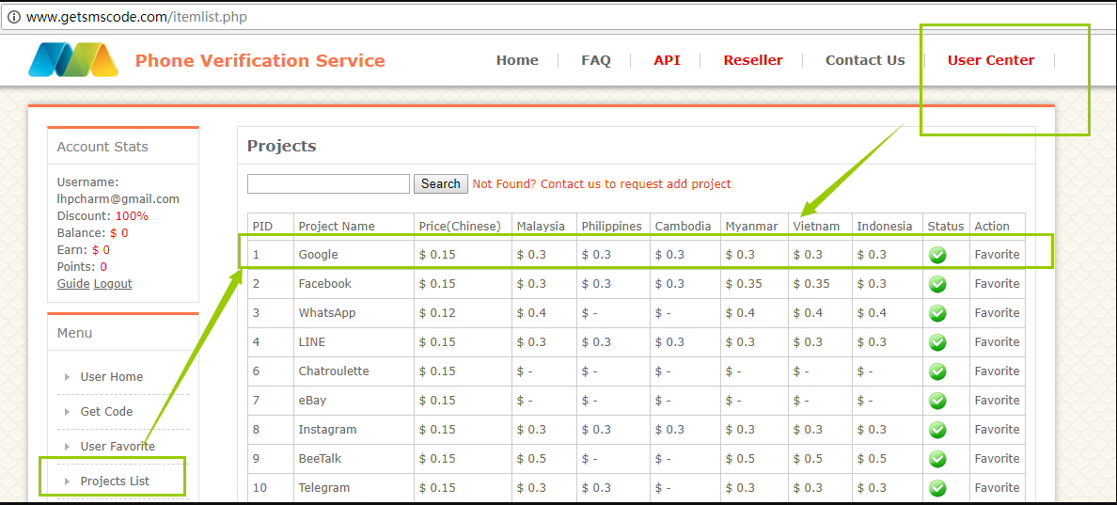
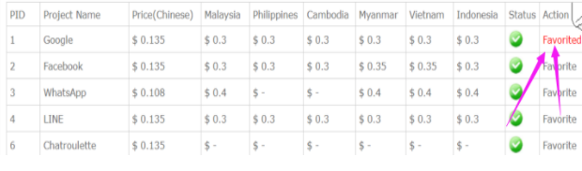
- After done the first step, click UserCenter, then please notice your username and token, for token , click Show me token button, then you will find your token.

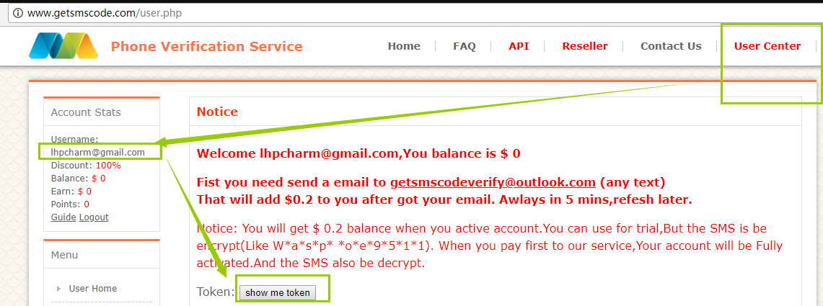
- Then please copy your username and token to pva gmail version:
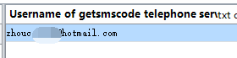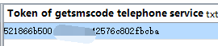

Note:
If you need to register many accounts, then you need to use proxy,then fill Proxy Manager variable: the program only support http proxy.
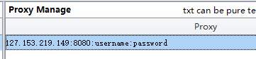

After you fill all register data, click Create Accounts first, then click Start to register account, and you can check the process and results in Accounts module.
