Manual for Mail.Ru

Click this character “+” to create a task, then just name it:
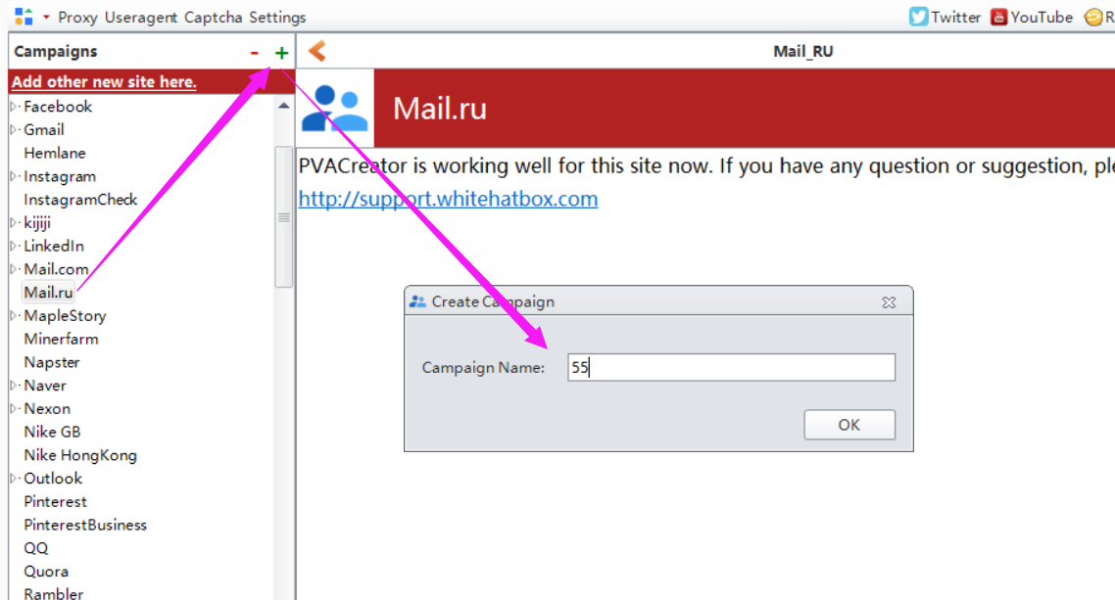

Following are the necessary variables needed to enter data before run：
1, Username&Kind
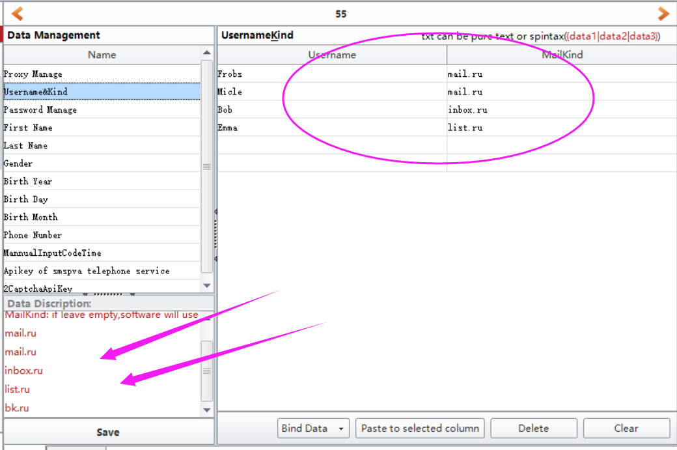
Username: must enter data for it. One username per row.
MailKind: it is to ask which kind of mail domain you will use during register. Following are the mail domain you can choose. If you do not enter data for this filed, then software will take one to use randomly.
mail.ru, inbox.ru, list.ru, bk.ru

2, Phone number&ManualInputCodeTime&Apikey of smspva telephone service
This one is to ask if you want to use yourself phone number to verify register.
- If yes, then please enter yourself phone number in “Phone Number” filed. One phone number per row. Then enter a pause time in “ManualInputCodeTime” filed, please enter a larger pause time and confirm you have enough time to get and enter the code manually from your phone. Eg: 10000000000
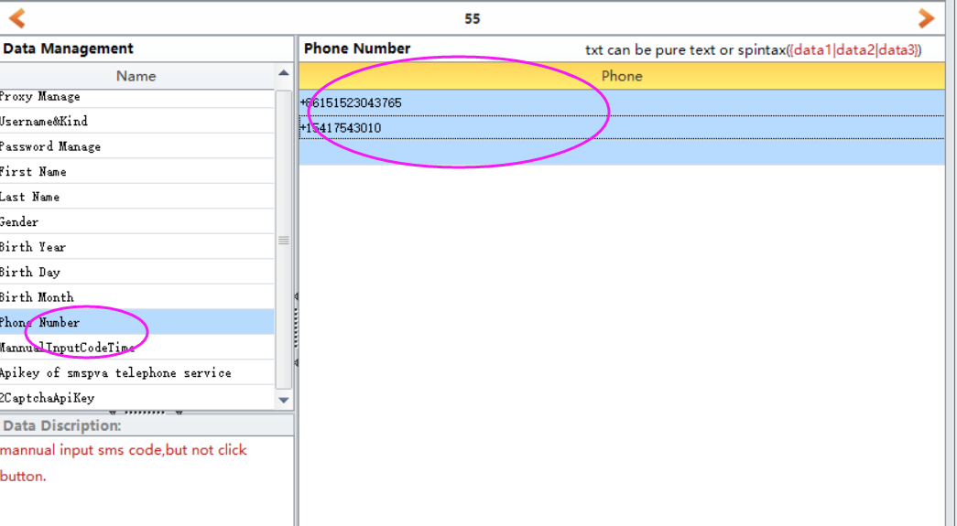
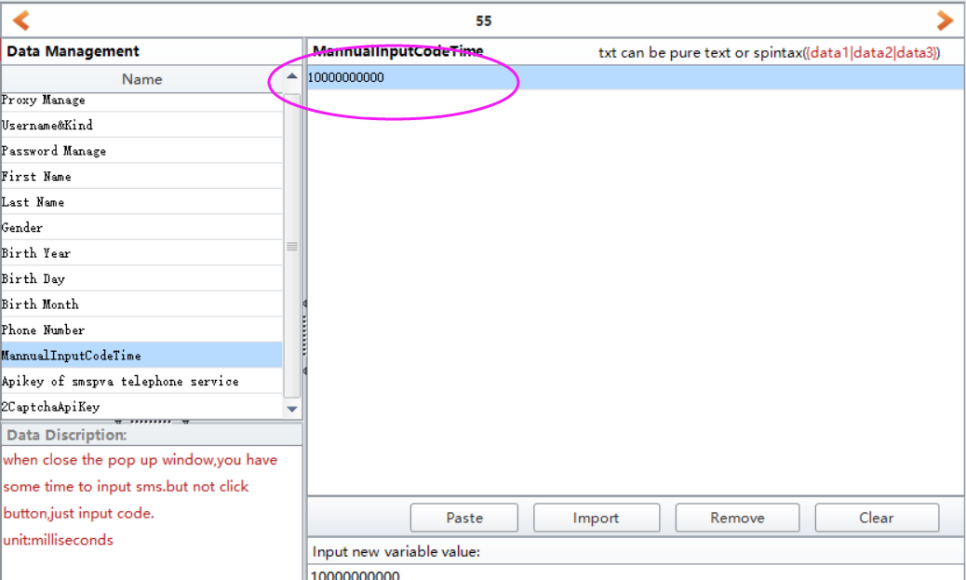

- If no, please register an account in smspva, then charge for your account, then you can find your account apikey in your account profile panel. Then enter it to “Apikey of smspva telephone service” field.
http://smspva.com/
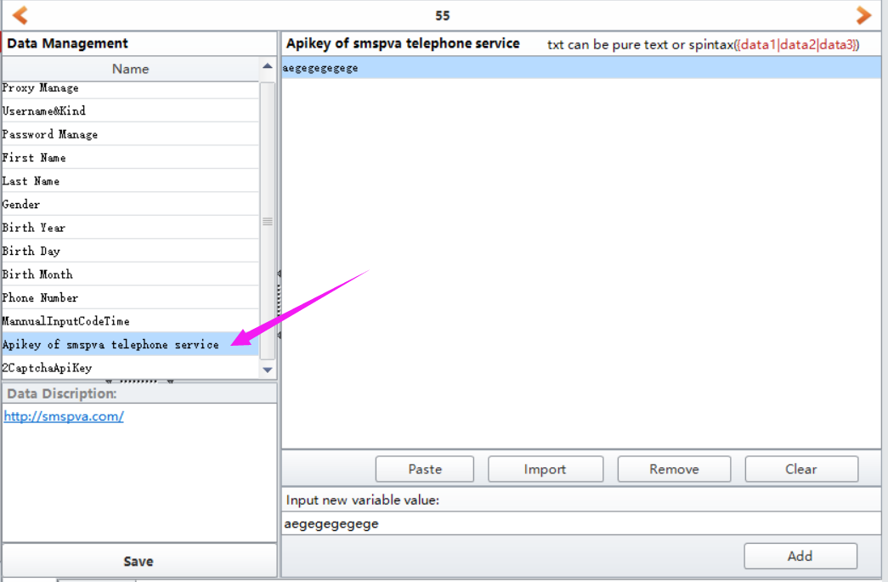

3, 2captcha ApiKey
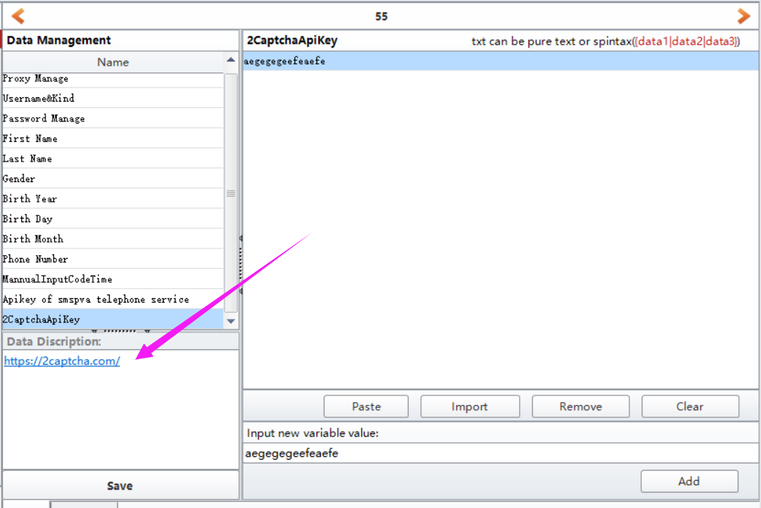
Visit 2captcha website, then register an account, then charge for your account, then enter your account apikey in this filed. If Twitter asks for captcha during register, then software will auto use this service to auto solve it.
https://2captcha.com/

4, Proxy Manage
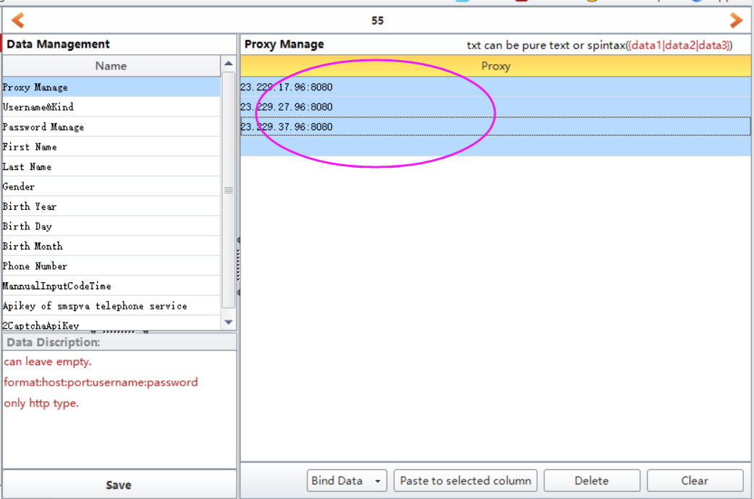
If you do have proxies and wish to create many accounts, then please enter your proxies in this filed. Please use HTTP proxy.
Proxy format can be: ip:port or ip:port:username:password
Eg: 23.219.57.96:8080 or 23.219.57.96:8080:proxy username:proxy password

5, Save
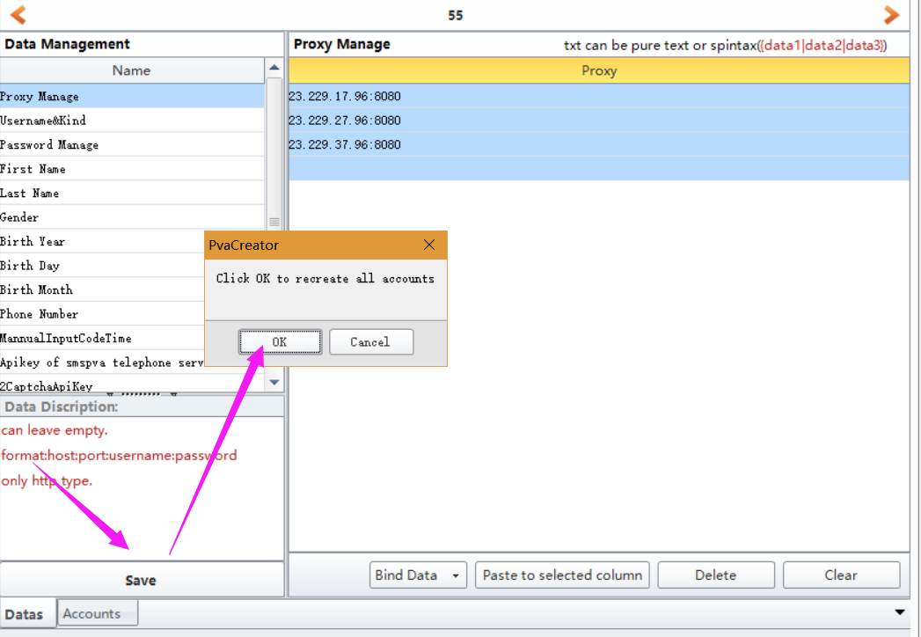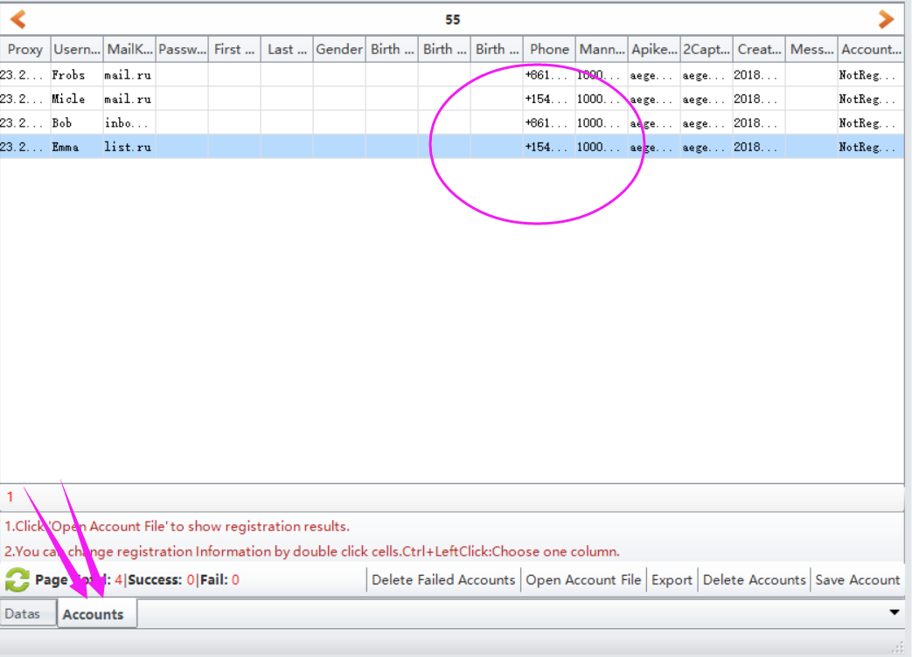

6, click Start button to start to run.
When it starts to run, here will be a debug window open, and you can view the whole running process.
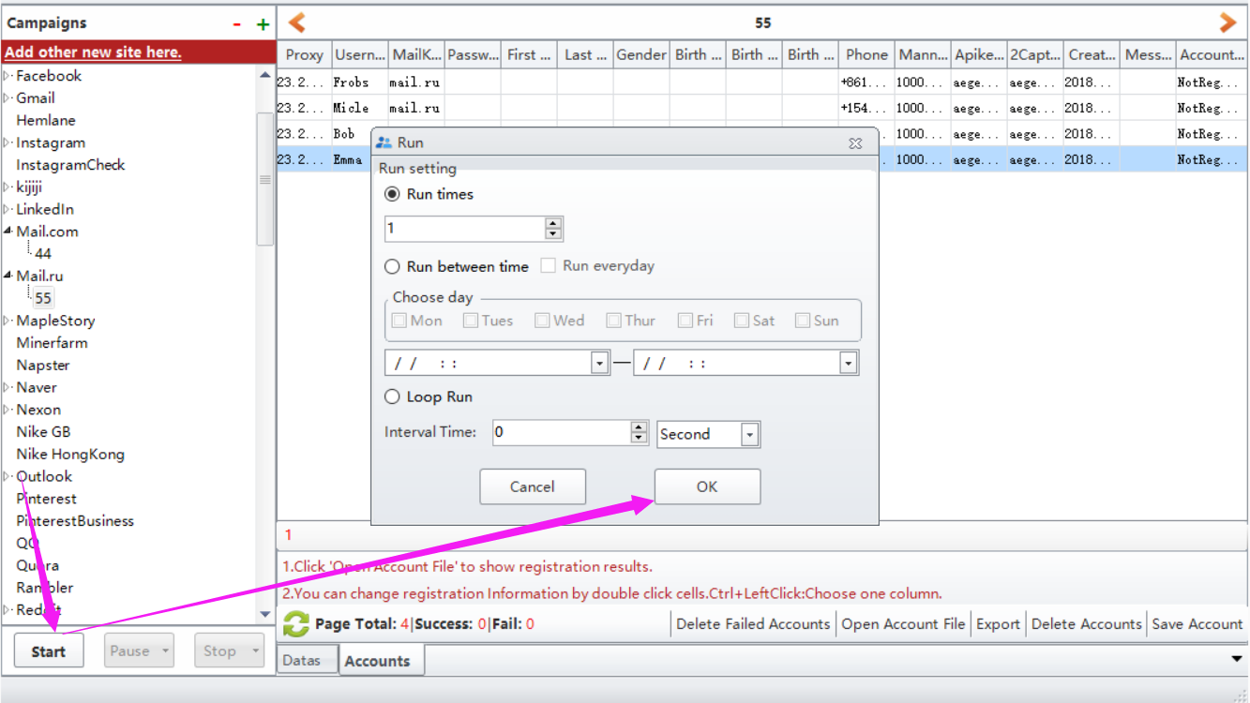

Options under “Bind Data”:
Import from file: import the data from your local prepared file at a time. Note: please choose the column first where you need to upload the data to.
UseRandom: custom some letters, numbers to auto generate data for these information. Such as full name, age, password. Note: please choose the column first where you need to custom and auto generate data.
Eg: if the first character is Funny, i will auto generate 1-4 number behind it. The first picture is the settings, the second one is the result it generates.
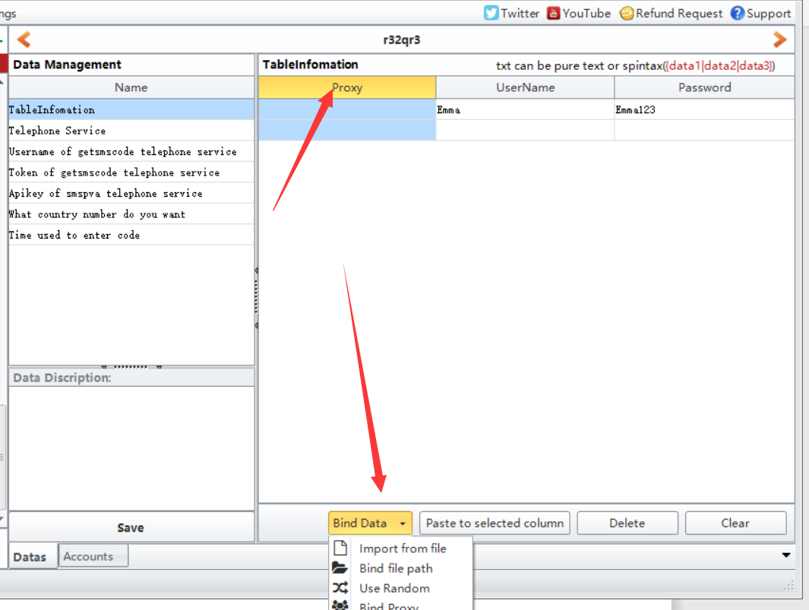
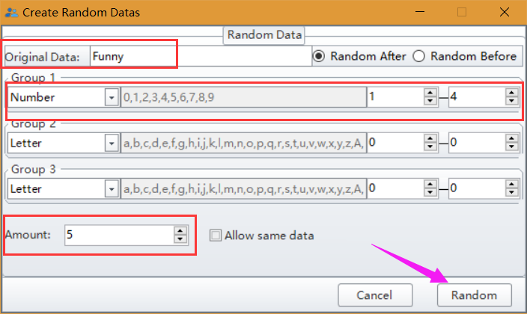
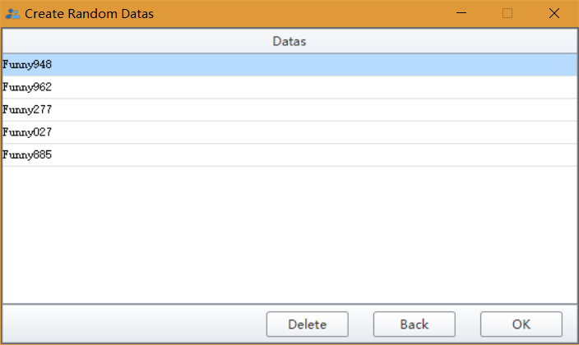
Bind Proxy/Useragent: bind proxy/useragents to these data at a time.

