Click + to create a campaign first:
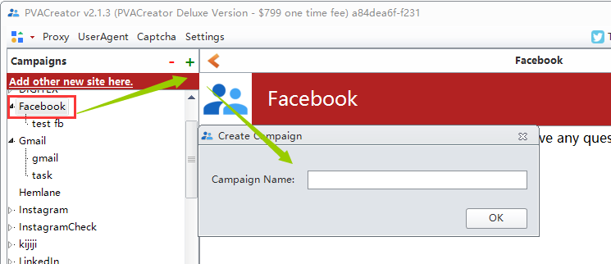
1.There are 2 variables you must fill : Email and CApiKey
About Email, please login your email in your local browser, then find server , port , protocol and SSL in settings module
For 2captcah apikey, please register an account at 2captcha.com , then charge your account, then you can find your api and fill it to the program.
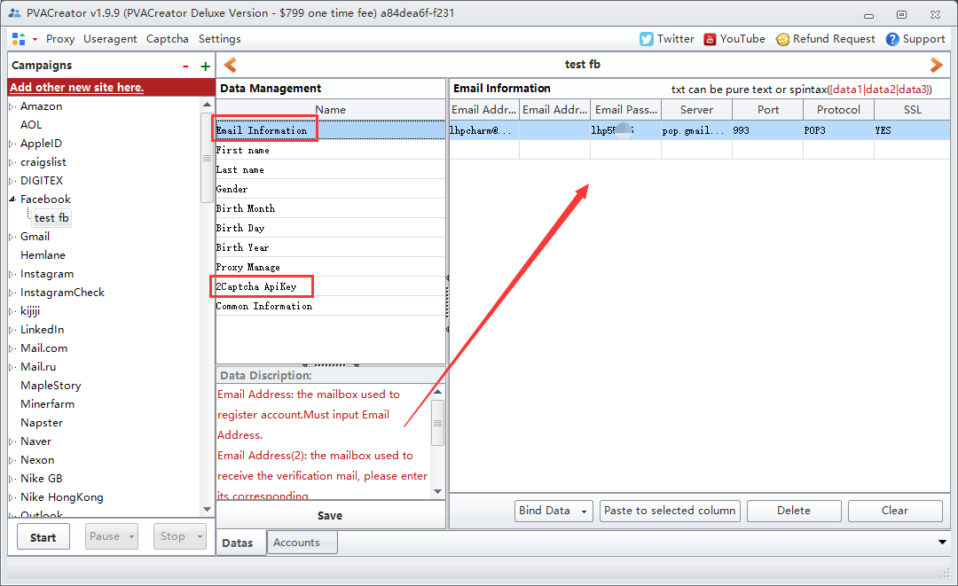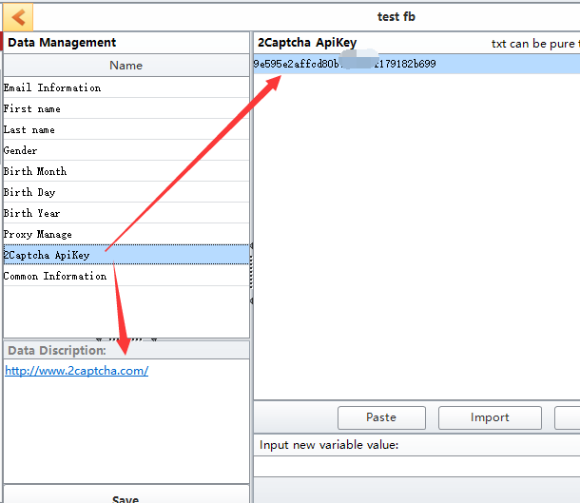
- Others variables, you can fill them according to your needs or leave them empty.
- Table Proxy: You can import http proxies from your local file(txt or csv), or you can add them manually, one proxy per line.
The proxy format is: for example: 127.153.219.149:8080 or 127.153.219.149:8080:username:password
- After filled all register data, click Create account, then click Start to run the task:
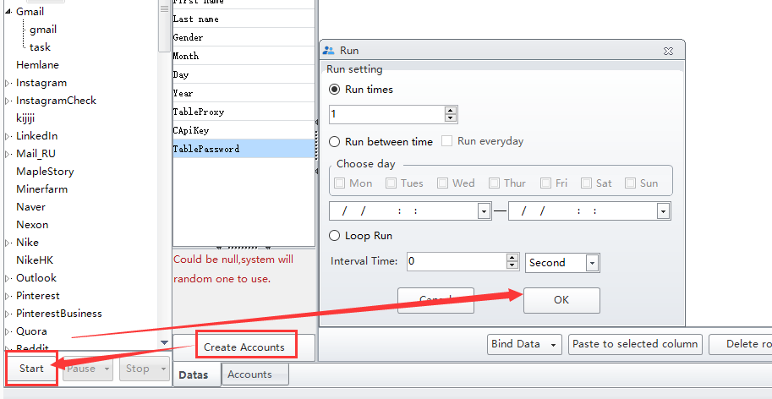
- You can check the account register process in Account module:
