Detailed Steps to Register Facebook Accounts

1. click this button “+” to create a task
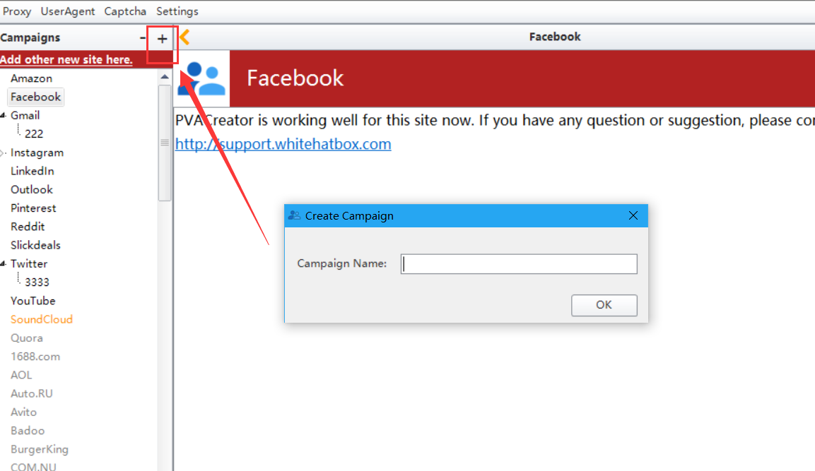

- enter your email address/email password/email server/email port/email protocol/SSL. You can search your email server/port/protocol in your browser manually. Protocol can be POP3 or IMAP.
Eg: if the email address i enter is sunnyyong43@outlook.com here is the outlook server i searched out from the browser, please only use Incoming mail server.
https://www.outlook-apps.com/outlook-com-pop-settings/
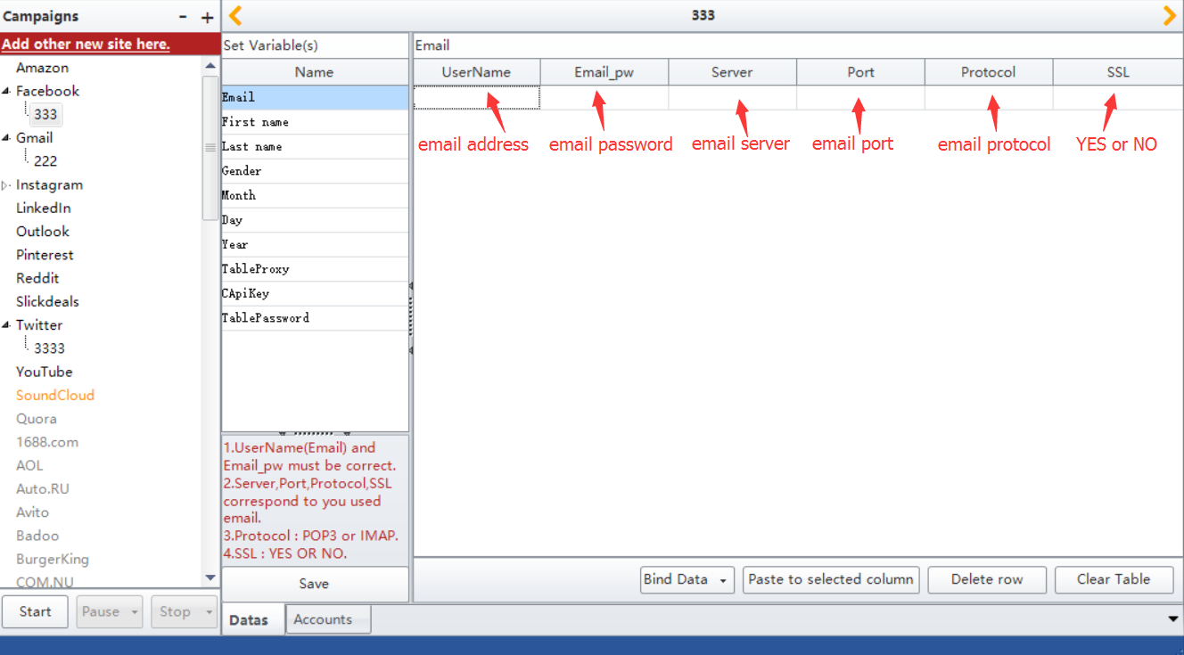

3. the value for “First name” and “Last name” can be empty. You can enter your own First name and Last name too. Follow the screenshot please
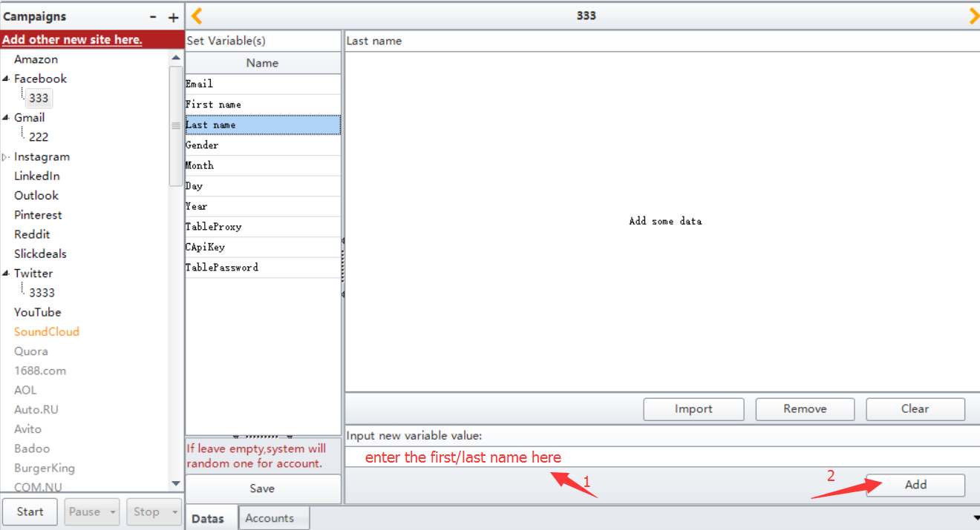

4. enter “0, 1, 2” to represent sex. 0-Male, 1-Female, 2-random choose one.
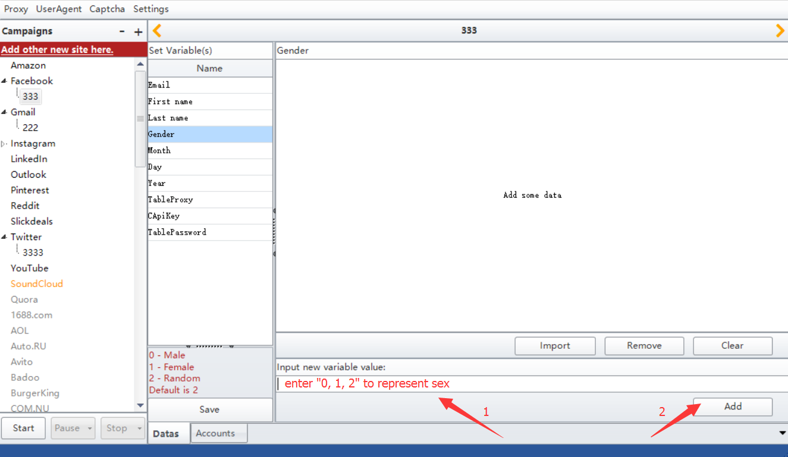

- the value for “Month”, “Day”, “Year” can be empty. You can enter your own value too.
Note: please enter 1-12 number to represent “Month”
please enter 1-31 number to represent “Day”
Please enter 1905-current year to represent “Year”
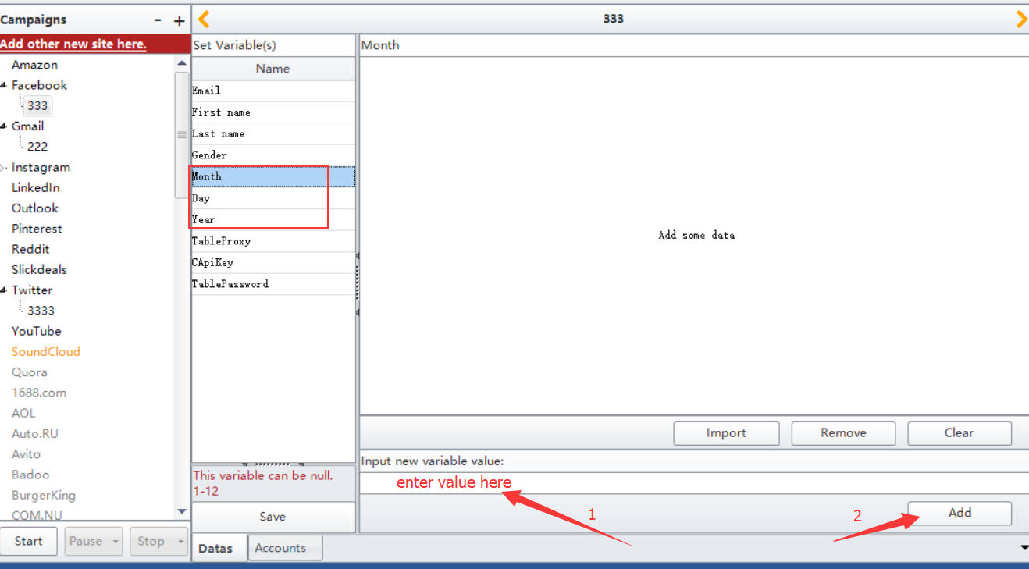

- the value for “TableProxy” can be empty. You can follow the screenshot to add your proxy too.
Proxy: it is to change your local ip to register. Please use http proxy. Proxy format: “ip:port” or “ip:port:username:password”
Recommend proxy website: http://www.squidproxies.com/
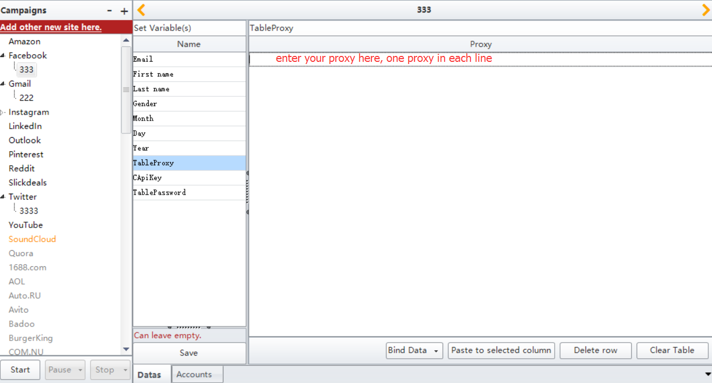

- enter your 2captcha account api to “CapiKey”.
Please register an account at this website: http://www.2captcha.com/ then charge for your account, then find your account api.
“CapiKey”: it is to help you auto verify the appeared captcha when register
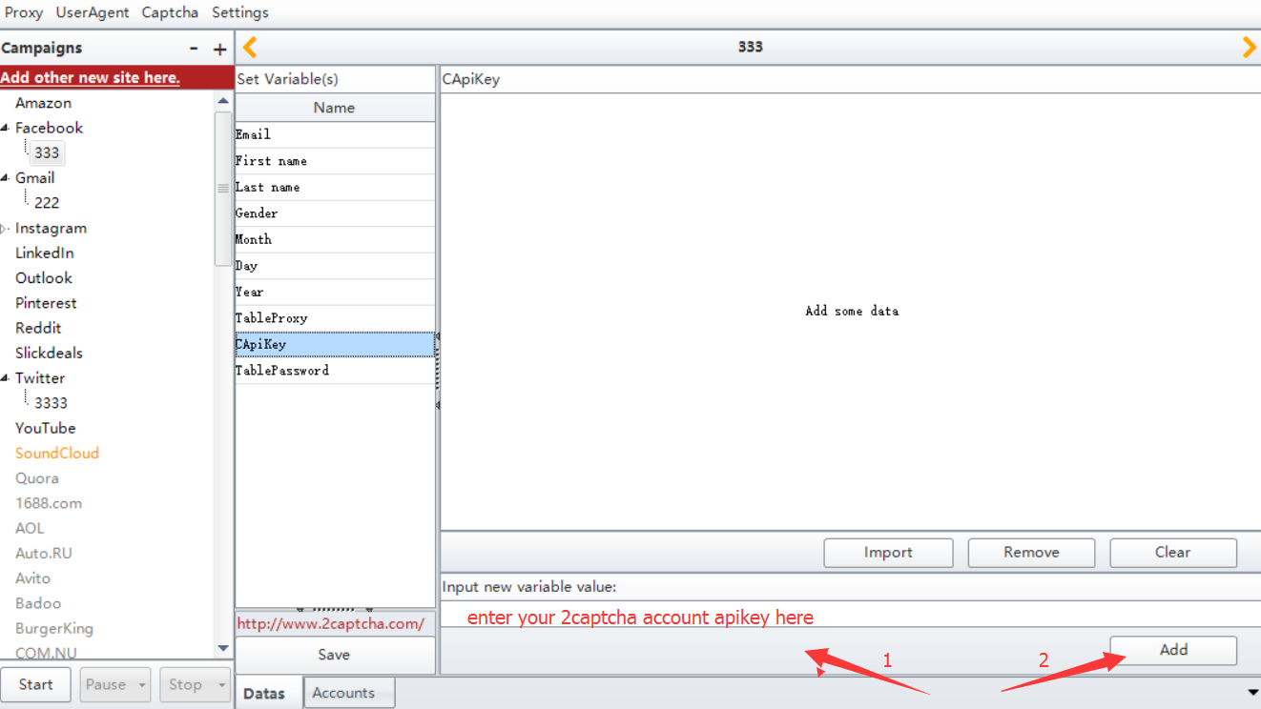

- the value for this one “TablePassword” can be empty. You can follow this screenshot to add your own password too.
“TablePassword”: if this is no value for it, program will auto generate one.
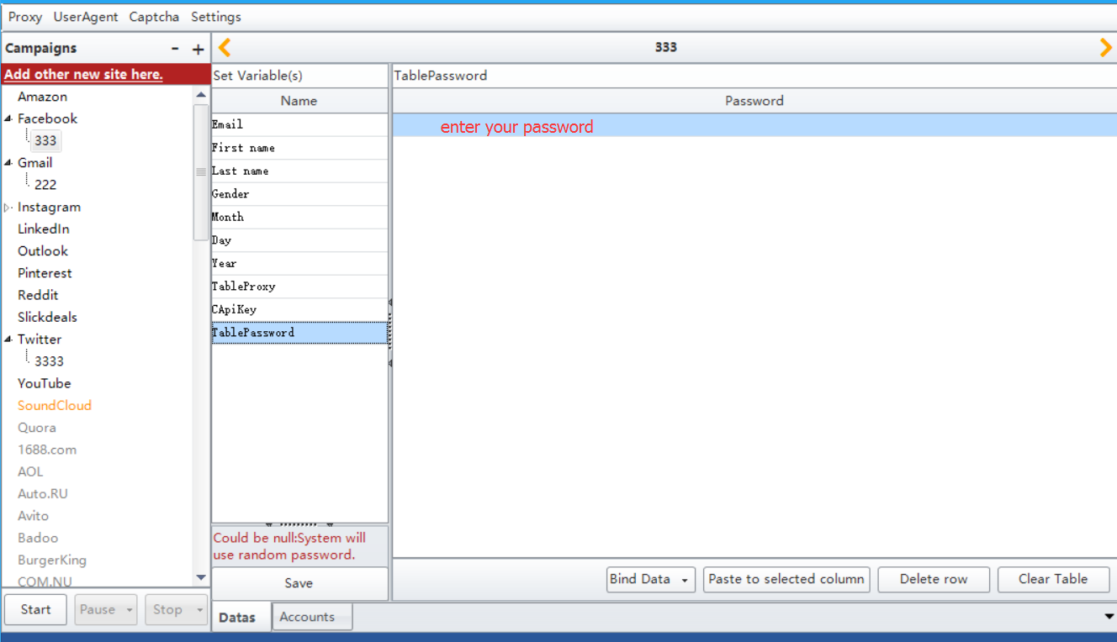

9. click “Save” button to save the data you entered
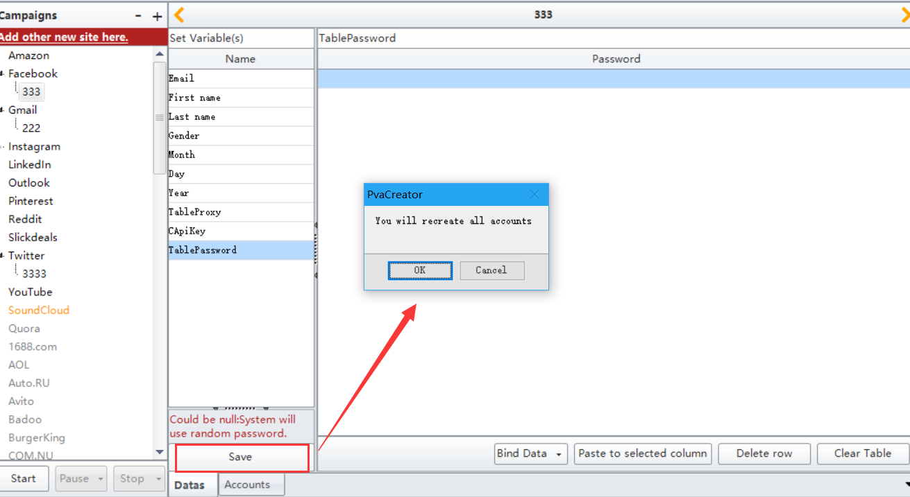

10. choose “Account” to view all data you added in this interface. Once the account registered success, the last column “AccountStatus” will be True.
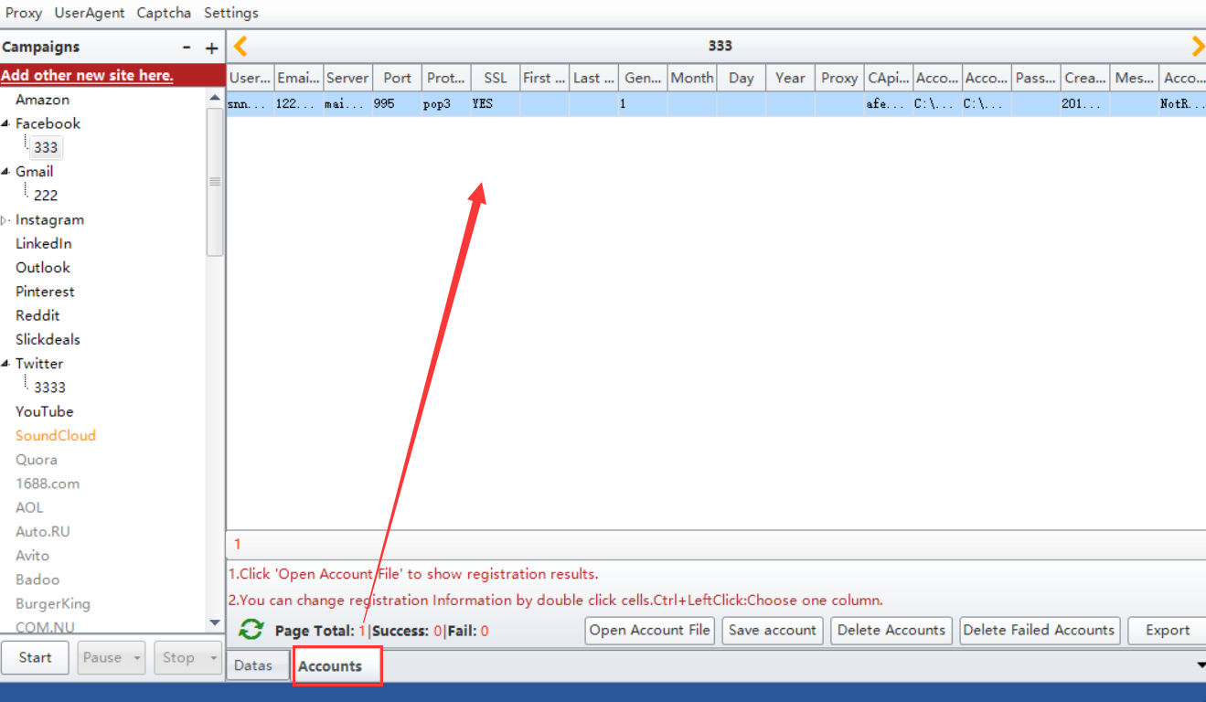

11. click “Start” button to run the task.
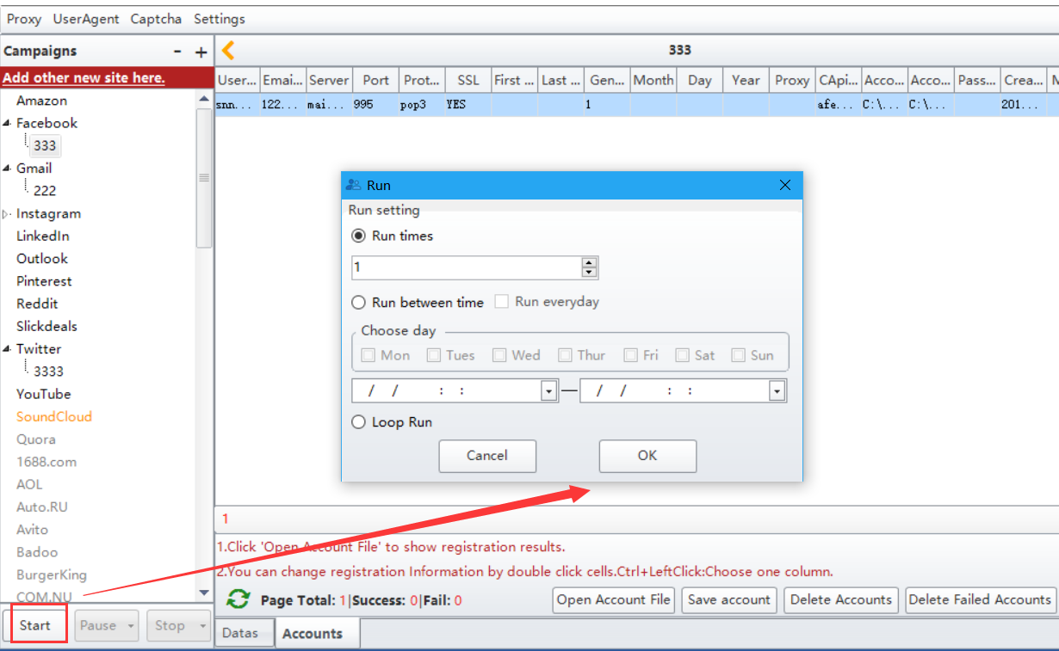

Notification:
You can use the “Bind Data” function to enter your data easily .
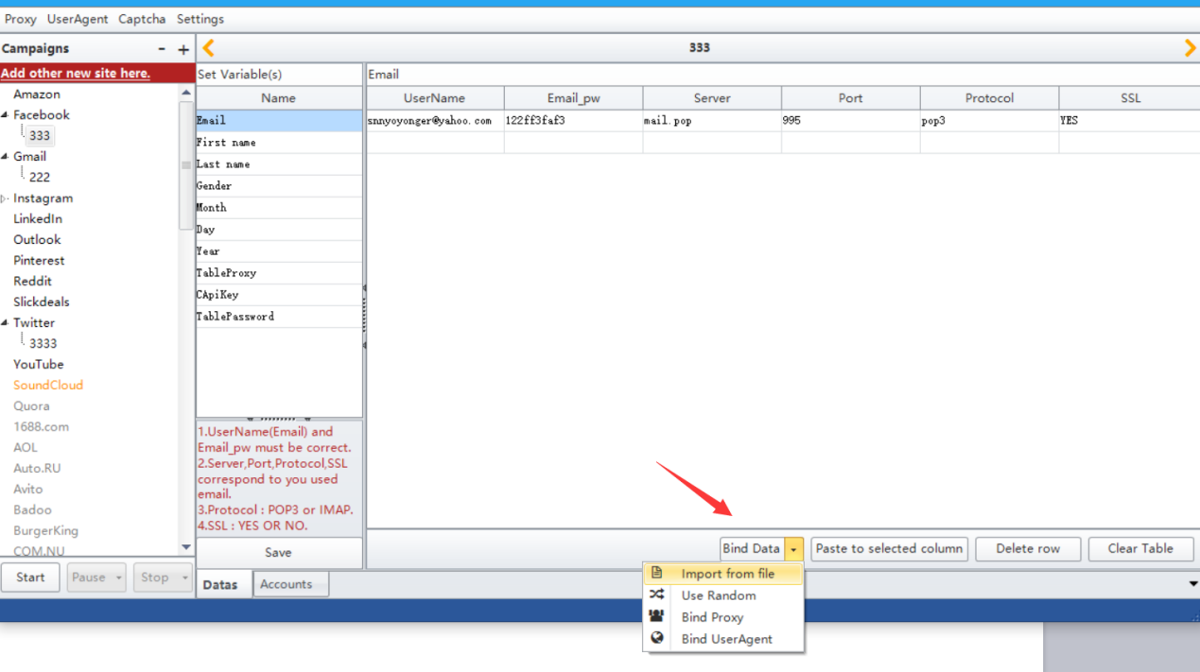
“Import from file”: import multiple data from your prepared local file once.
“Use Random”: randomly combine letter/number/special character to easily generate the data.
“Bind Proxy”: one click to add proxy for all data to register.
“Bind Useragent”: one click to add useranget for all data to register.

