You can choose any methods to setup your task.
Method1: Options you have to enter value when choose smspva phone service to register:
UserNameTable: the username you want to use when register.
Sex: enter number 1-4 represents male, female, not say, and other. 1-male, 2-female, 3-not say, 4-others
EmailTable: the recovery email address. We suggest enter your email address. Because if Gmail asks you verify this account in the future, then you can find your account back easily.
FirstAndLastNameTable: the first and last name you will use when register.
ProxyTable: please use http proxy or mobile proxy. The proxy format is: ip:port or ip:port:username:password
ApiKey: enter your smspva account apikey here. Register an account in smspva.com, then charge for your account, then you can find the apikey in your account profile.
IsUseMailSetting: this one means if you will go to edit the email account pop/imap settings after registered account successfully. Please enter value 0 or 1. 0-no, i do not want to edit the mail settings. 1-yes, i need to edit the mail settings.
PhoneService: enter 1. 1-use smspva phone service to solve the phone verification.
PhoneCountry: choose which country phone number you want to use from smspva. Eg: 0-Russian, 1-Latvia

Method2: Options you have to enter value when choose getsmscode （Recommend phone service） phone service to register:
UserNameTable: the username you want to use when register.
Sex: enter number 1-4 represents male, female, not say, and other. 1-male, 2-female, 3-not say, 4-others
EmailTable: the recovery email address. We suggest enter your email address. Because if Gmail asks you verify this account in the future, then you can find your account back easily.
FirstAndLastNameTable: the first and last name you will use when register.
ProxyTable: please use http proxy or mobile proxy. The proxy format is: ip:port or ip:port:username:password
SMSUserName: enter your getsmscode account username. Register an account in getsmscode.com then charge for your account, then you can find your getsmscode username.
SMSToken: enter your getsmscode account token. Register an account in getsmscode.com then charge for your account, then you can find your getsmscode token.
IsUseMailSetting: this one means if you will go to edit the email account pop/imap settings after registered account successfully. Please enter value 0 or 1. 0-no, i do not want to edit the mail settings. 1-yes, i need to edit the mail settings.
PhoneService: enter 0. 0-use getsmscode phone service to solve the phone verification.
PhoneCountry: choose which country phone number you want to use from getsmscode. Eg: 0-Chinese, 1-Cambodia
How to create the task?
- Click this character “+” to create a task, then just name it:
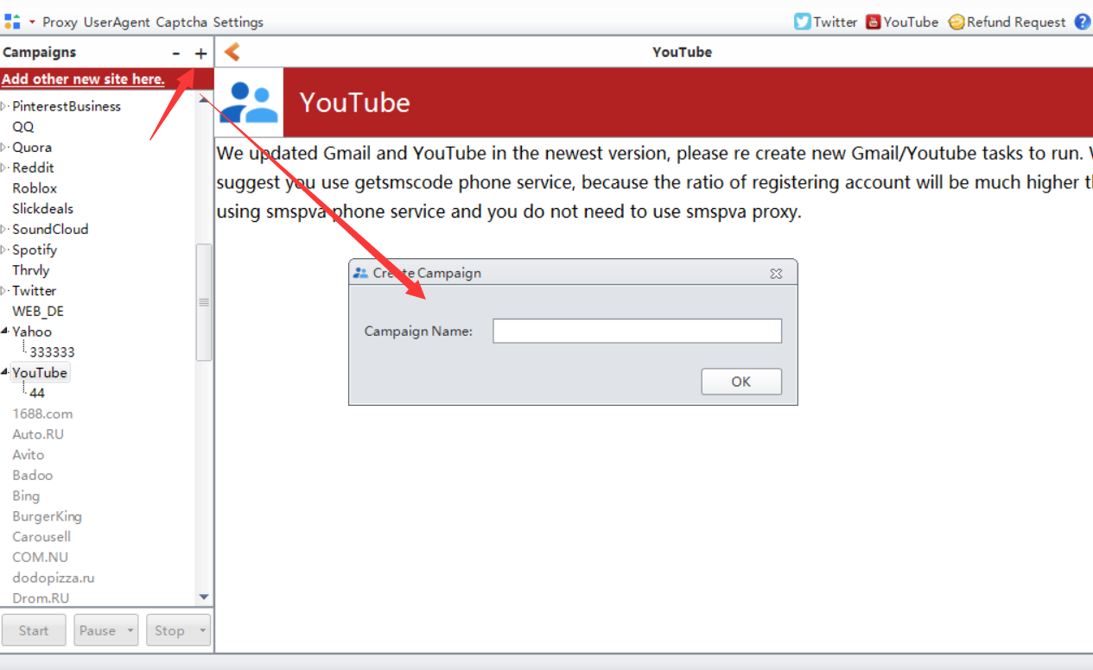

How to enter value for these options?
1. manually input value for them one by one.
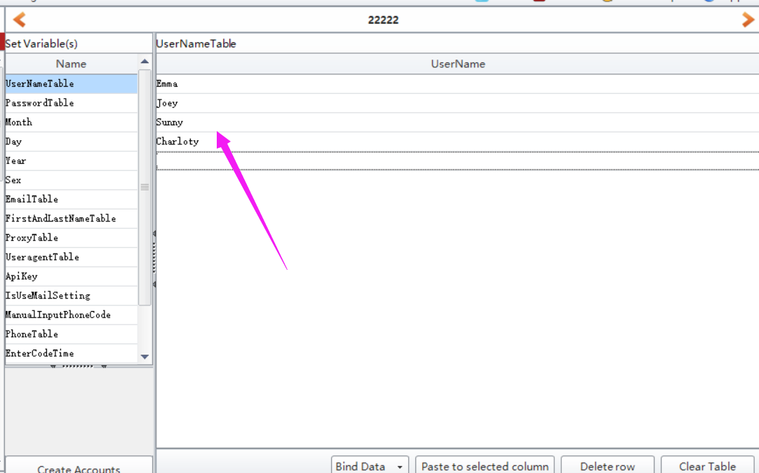
- click “BindData” to choose “Import from file” option to upload multiple data at a time.
Note: please check this column (the checked column color will be yellow) first which you need to multiple upload data.
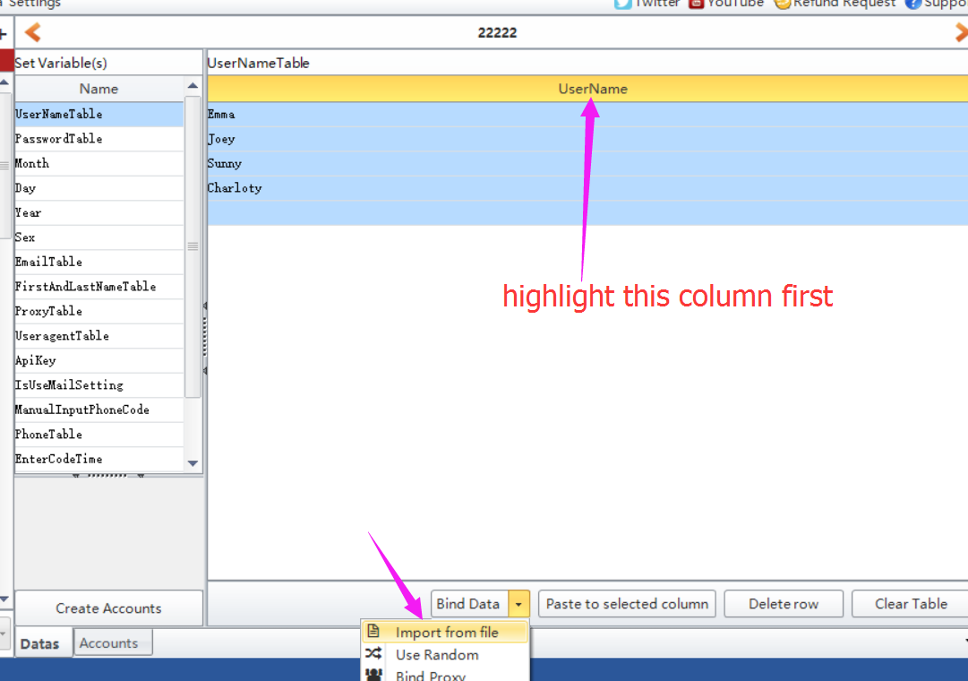
- click “BindData” to choose “Use Random” option to auto generate some data based on the condition you preset.
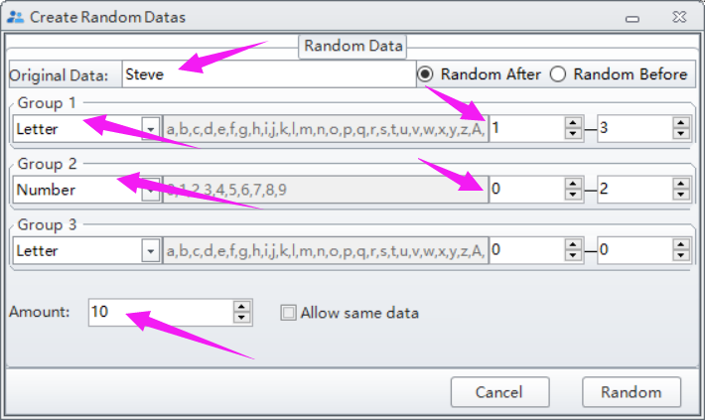
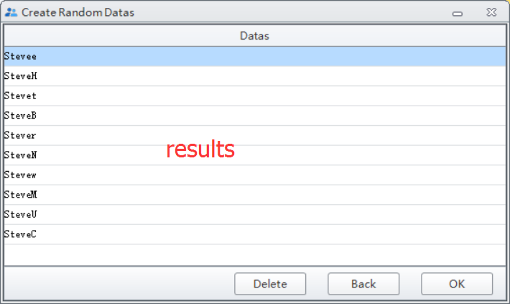

Note: please do not forget to click “Create Account” button to save the data you entered/modified.
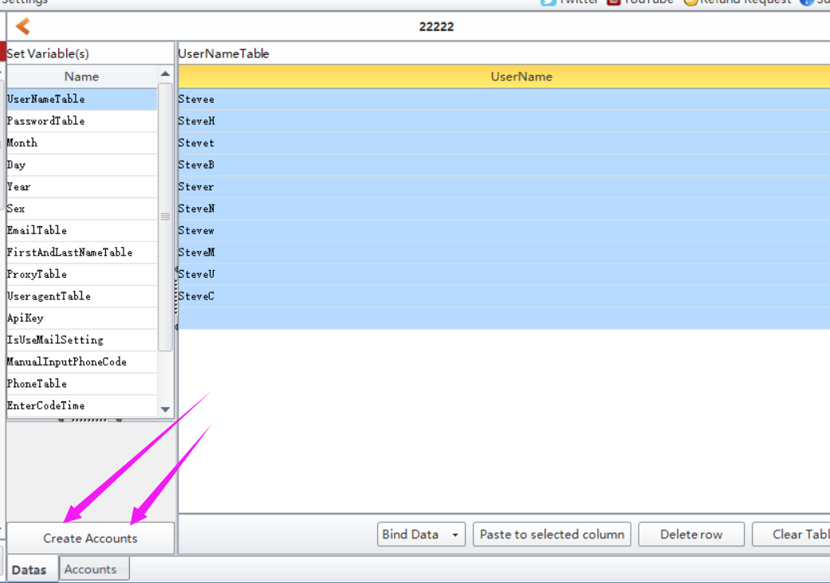

Where to find the data i entered?
Click Accounts button, then you can find all data you entered in this form:

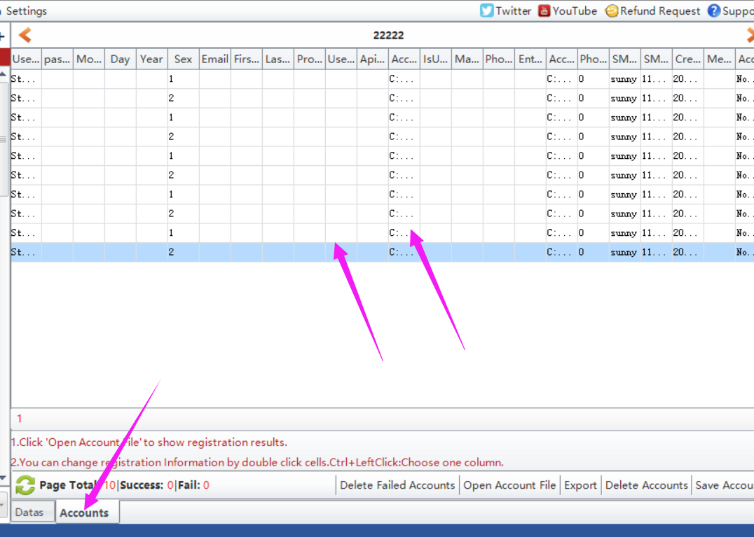

Where to start to run the task?
Click Start button to run.
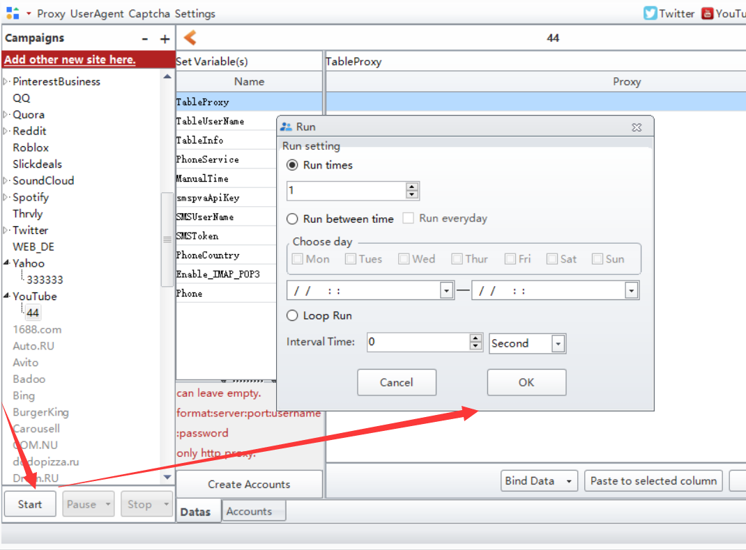

Following is the data needed to enter before run:
TableUserName:
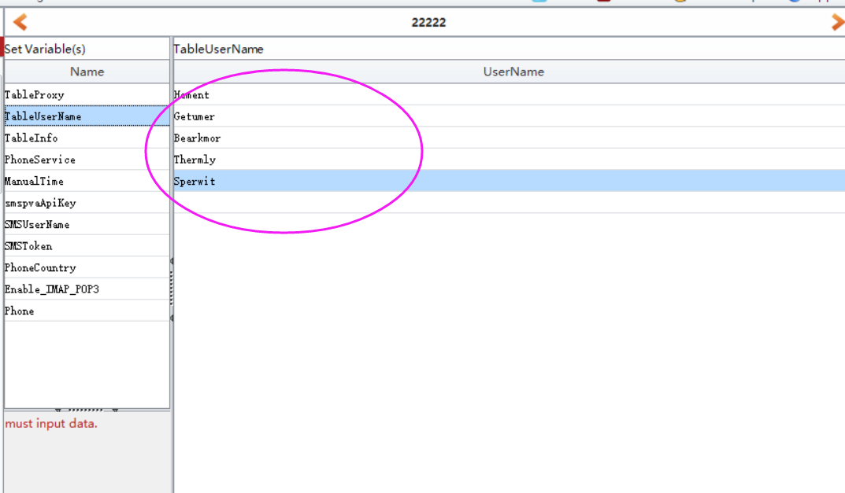
TableInfo: all data can be empty except the recovery email. If Gmail asks for email verification in the future, then you can get your account back via your recovery email.
PhoneService: enter 1 or 2 to choose which phone service you will use. Here are 2 phone services you can choose. One is getsmscode, the other is smspva
smsApiKey: enter your smspva account apikey here. Register an account in smspva, then charge for your account, then you can find your account apikey in your profile field.
SMSUserName/SMSToken: enter your getsmscode account information here. Register an account in getsmscode, then charge for your account, then you can find your account username and token.
PhoneCountry: choose which phone service and which country phone number you will use to register account.
Please choose one of phone service to use. If you have proxy, you'd better enter your proxies to TableProxy to register. Please use HTTP proxy.

Use own phone number to register:
Here are the necessary variables needed to enter data before run when you use your own phone number to register:
TableUserName:
TableInfo: You'd better enter your recovery email address to register which can help you find your account back if Gmail asks for verification in the future.
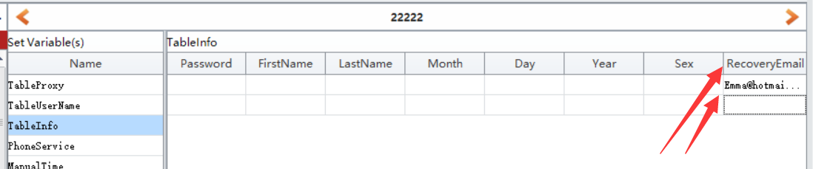
PhoneService: enter 0.
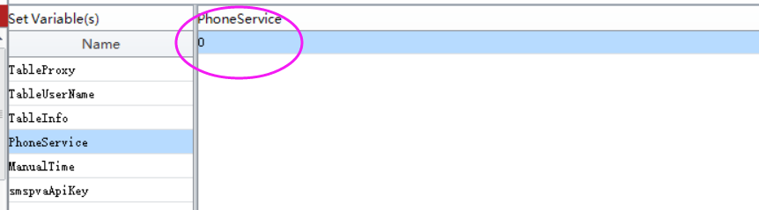
Manual Time: enter a time to pause the software for a while, then you do have enough time to enter your phone number and code to verify manually.
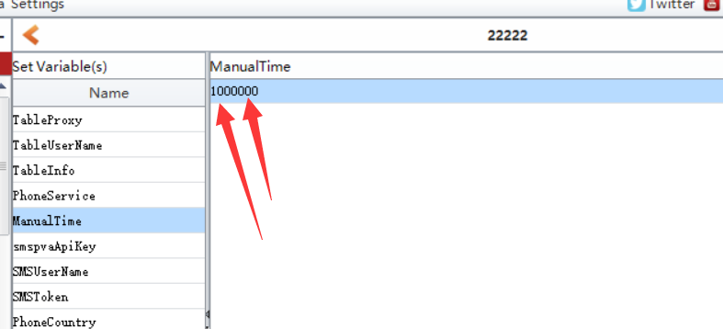
Phone: enter your phone number here. One number per row:
