Details about Creating YouTube Accounts

1. Double click the row to enter the username.
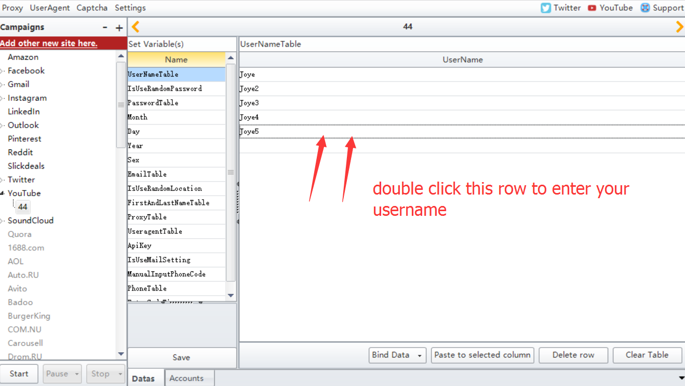

2. Enter “1” to let the program auto generate the password. If you enter “0”, then please enter yourself password in “PasswordTable” option.
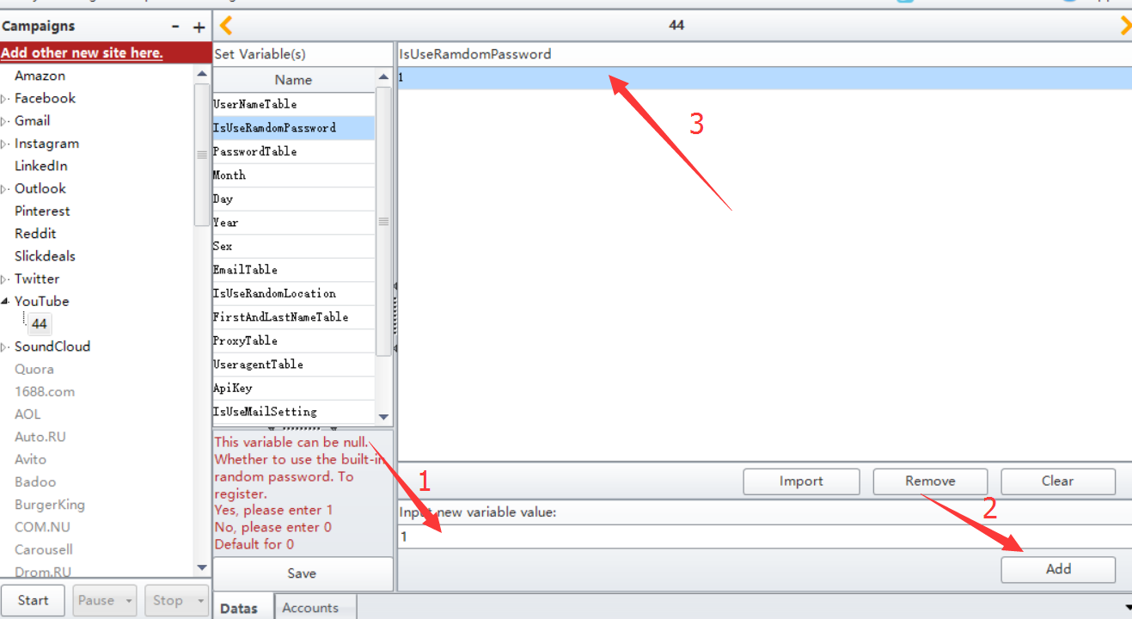

- Choose one value from this list “:1, :2, :3, :4, :5, :6, :7, :8, :9, :a, :b, :c ” to represent 1-12 months.
You can leave this option’s value to be empty, then program will auto select one from the list.
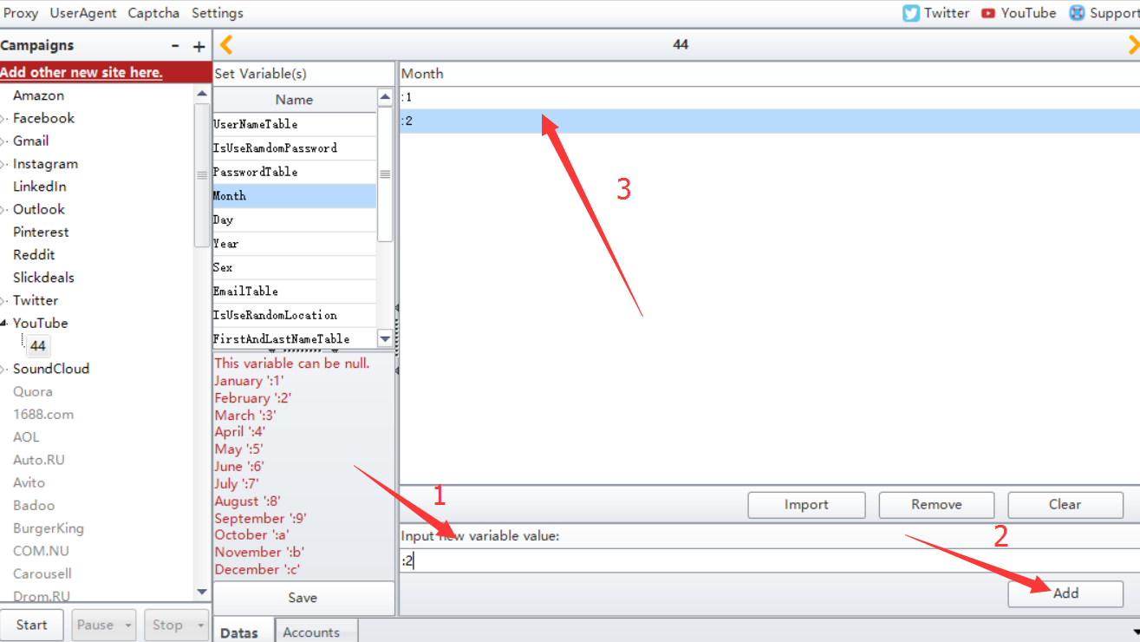

- Choose one value from this list “1, 2, ,3, 4, 5, 6, 7, 8, 9, 10, 11, 12, 13, 14......28/30/31” to represent days.
You can leave this option’s value to be empty, then program will auto select one from the list.
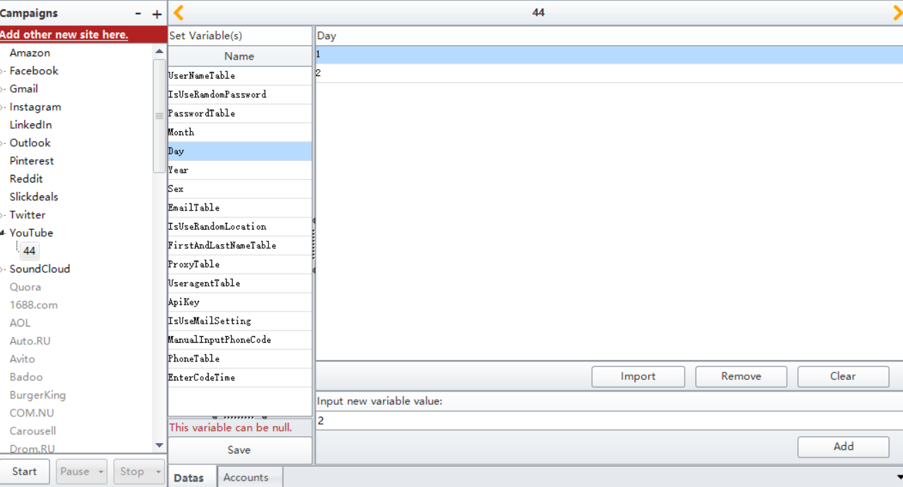

- Choose one value from the list “1905, 1905........2018” to represent years.
You can leave this option’s value to be empty, then program will auto select one from the list.
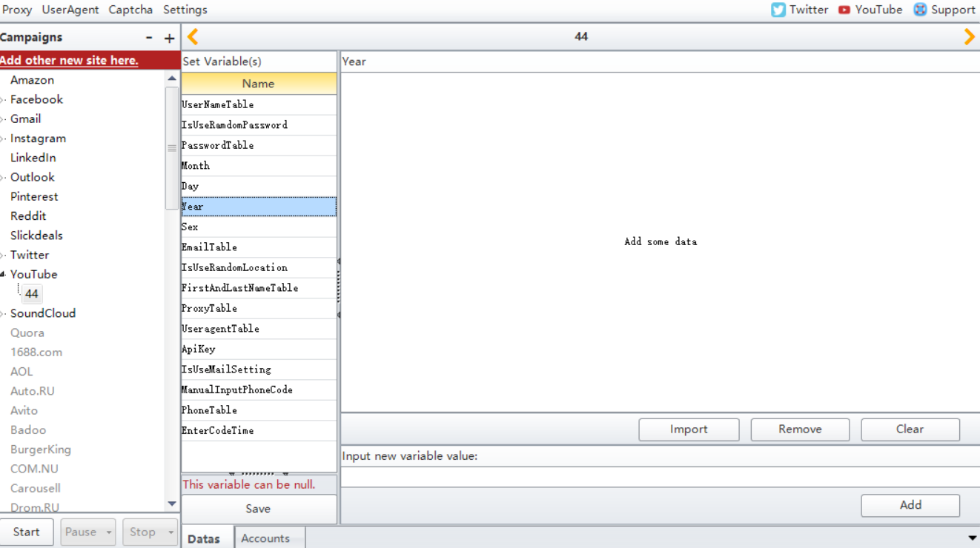

- Choose one value from the list “:e, :f, :g, :h” to represent sex.
:e----it represents Female
:f----it represents Male
:g---it represents random one
:h---it represents not tell the sex
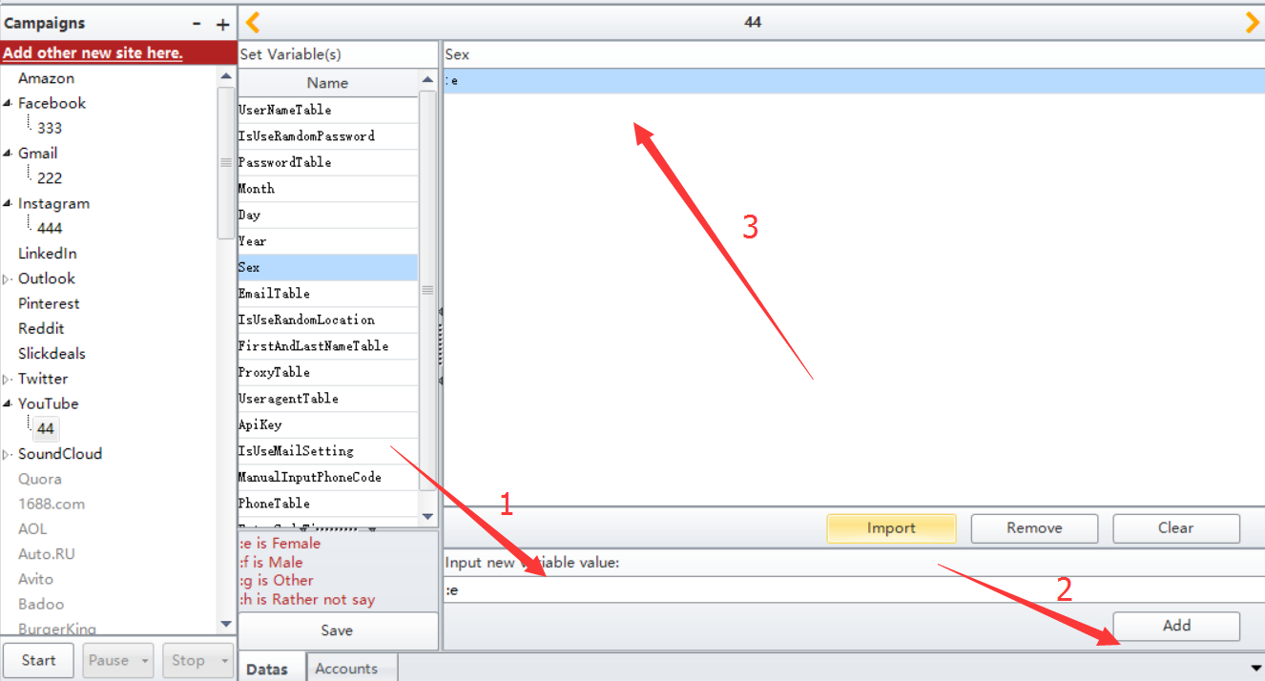

7. You can leave this option’s value to be empty. Or enter your recovered email address.
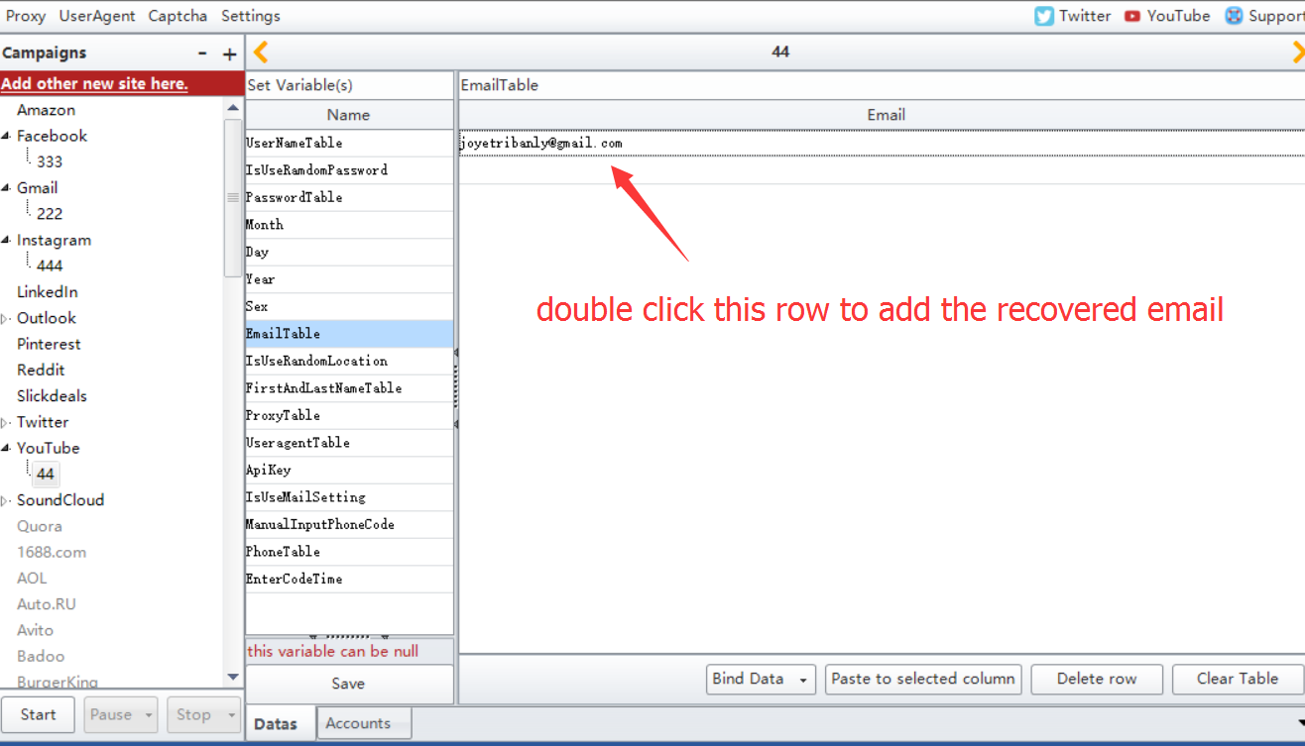

8. Enter the the firstname, last name. One value per row.
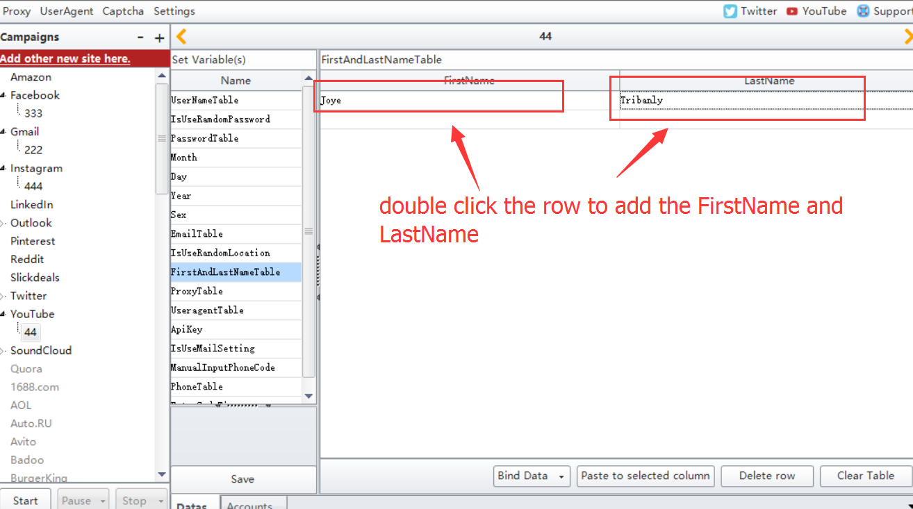

- The value for this option can be empty. But our suggestion is you’d better use proxy to register. Cause if there is no proxy, program will use your local ip to register.
Proxy format: ip:port or ip:port:username:password
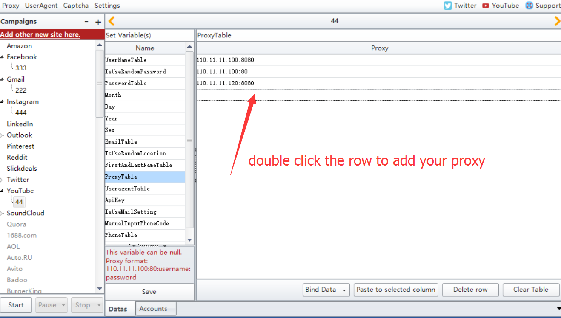

- The value for this option can be empty. But you can enter the useragent to register too.
Enter useragent in your browser, then you can find more.
Eg: Mozilla/5.0 (Windows NT 6.2; WOW64) AppleWebKit/537.36 (KHTML, like Gecko) Chrome/30.0.1599.17 Safari/537.36
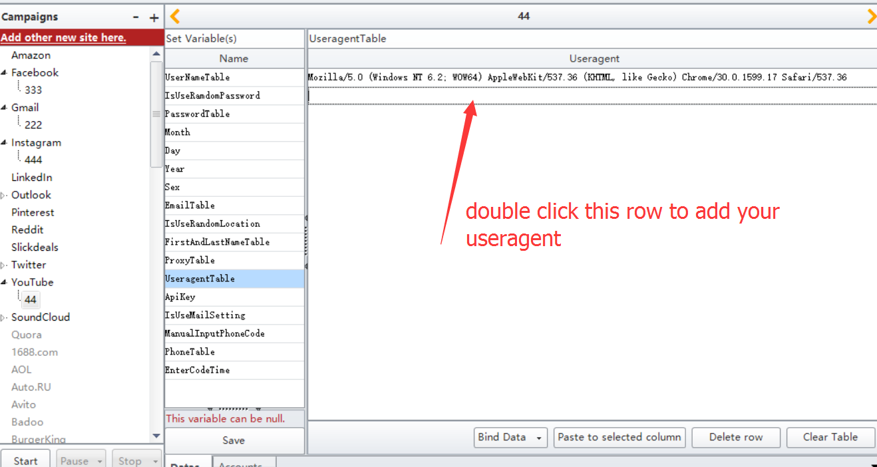

11. Use smspva phone number service to auto take and verify the phone when register. You can register an account in this website http://smspva.com/ then charge for your account. Then in your account profile settings, you can find the apikey
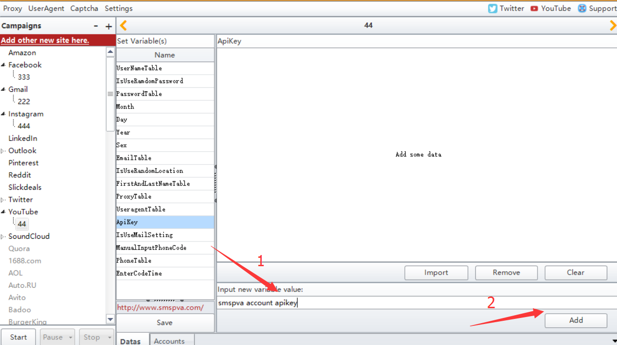

12. Enter “1” means program will go to edit the mail settings to pop. Enter “0” means no need to set this settings.
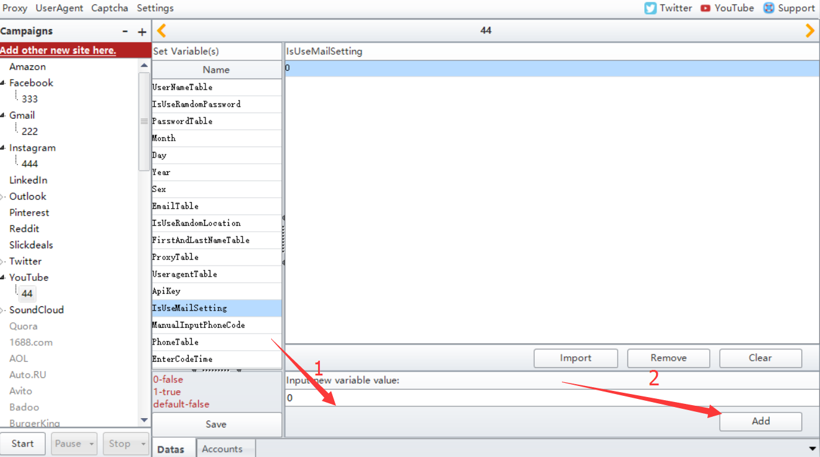

13. Click Save button to save the settings.
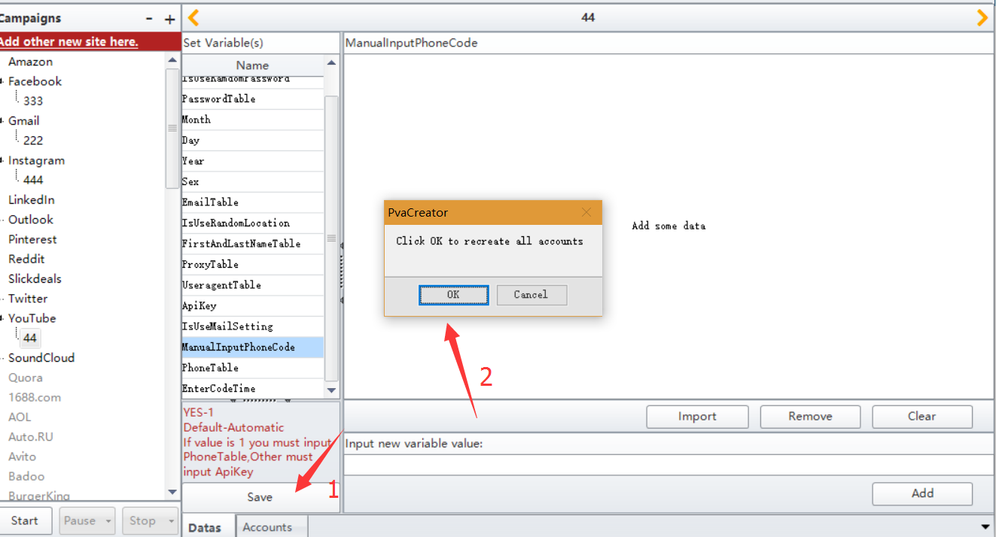

14. Click Account button, then you can preview the data you entered.
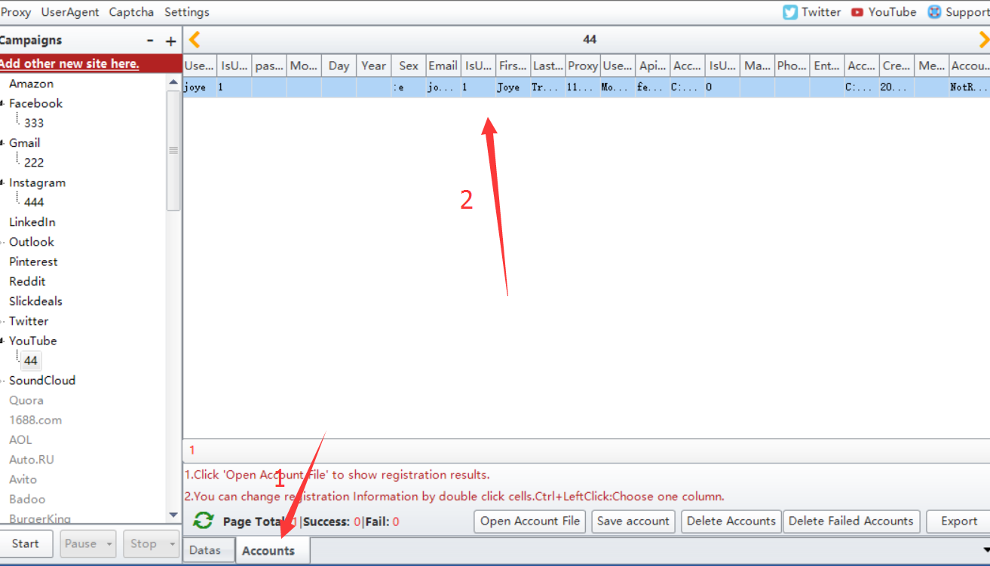

15. Click Start button to start to run.
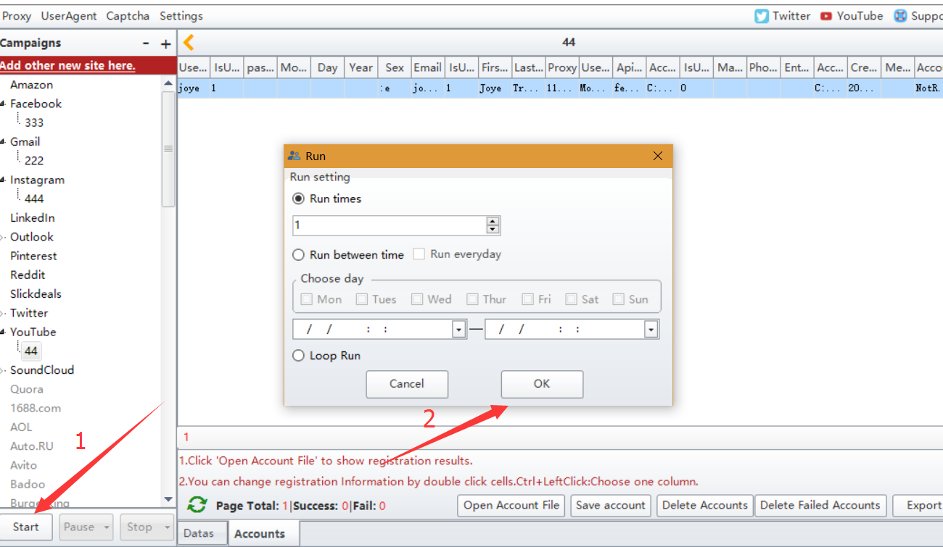

The above settings is to show you how to use the smspva phone service to auto take and verify phone when register.

You can enter yourself phone number to register too. But please enter value for these options:
ManualInputPhoneCode: enter value “1”
PhoneTable: enter yourself phone number
EnterCodeTime: enter the pause time to receive and input the phone code. The unit for it is millisecond

