POP/IMAP/SMTP Server Settings for Common Mailboxes
- Yahoo
Protocol | Server address | Port | SSL | In CladPin
POP | pop.mail.yahoo.com | 995 | Yes | No
IMAP | imap.mail.yahoo.com | 993 | Yes | No
SMTP | smtp.mail.yahoo.com | 465 or 587 | Yes | No

Obtain a 3rd party software login password:
- Click Account Info to view your account main interface.
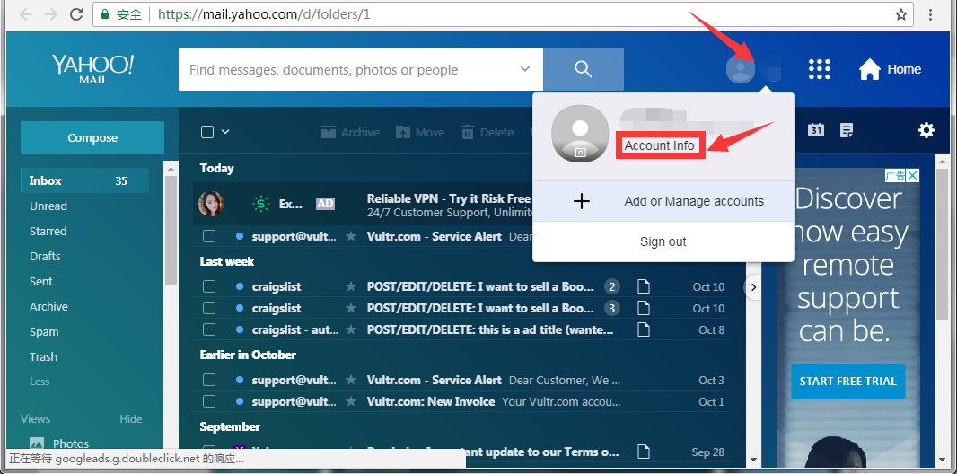
- In Account security option, turn on the “Two-step verification” button to verify your account via phone number.
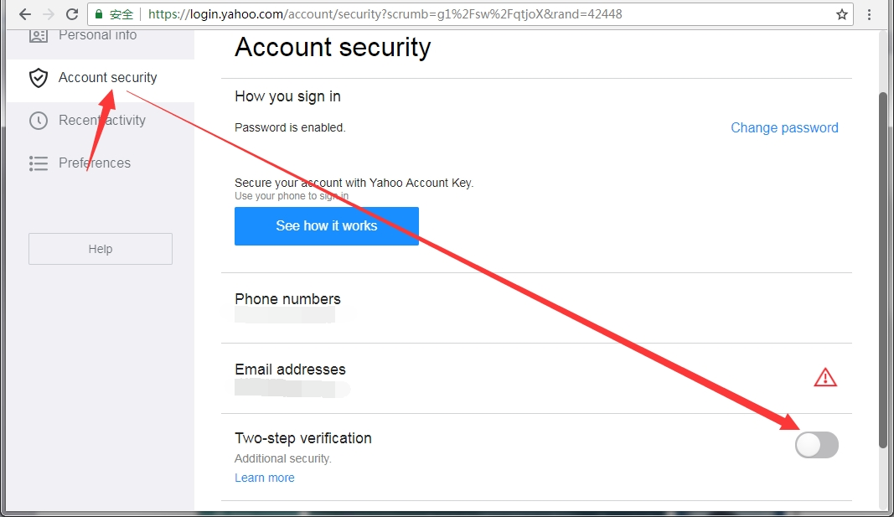
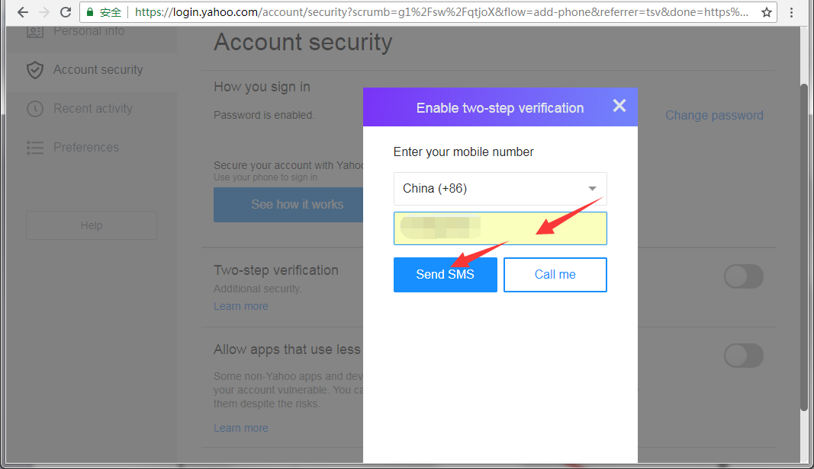
- Enter your phone code to verify it, then click Create app passwords button to generate a password.
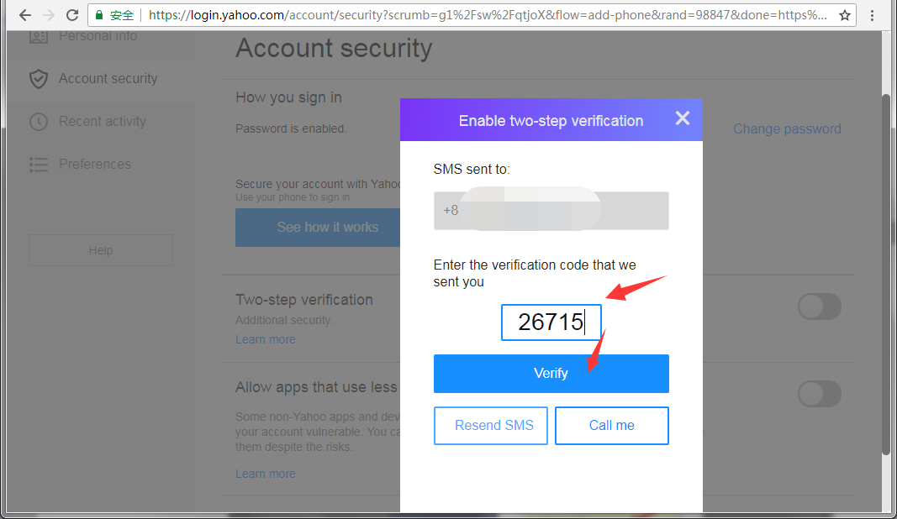
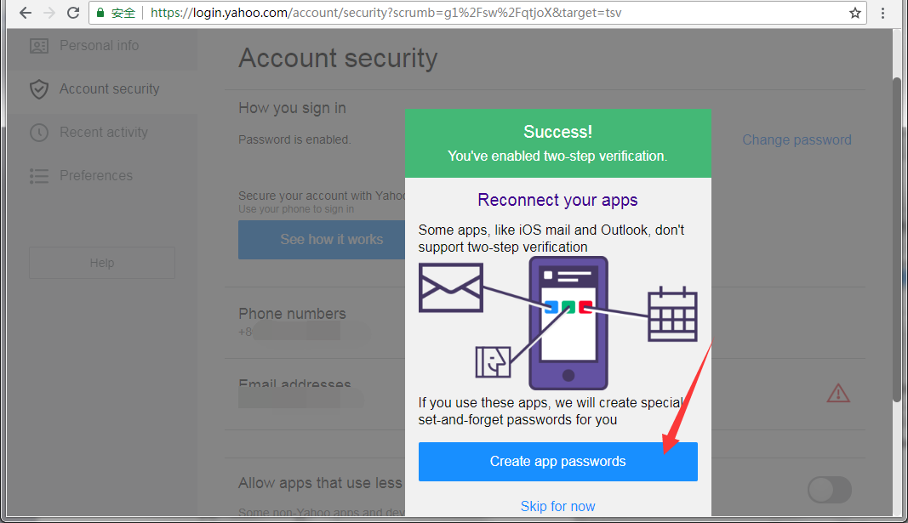
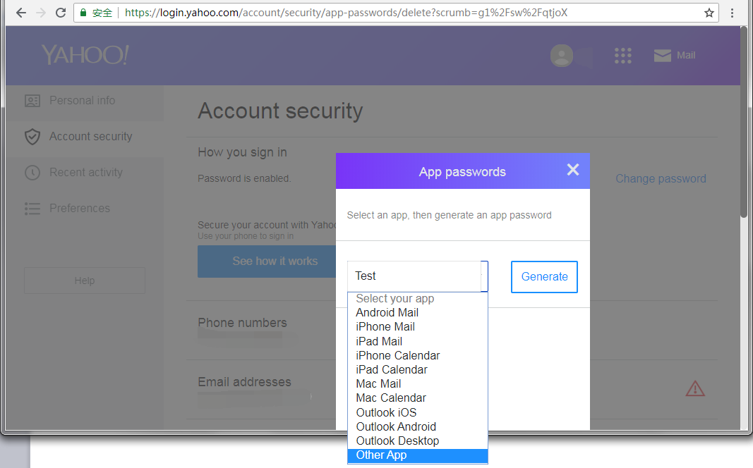
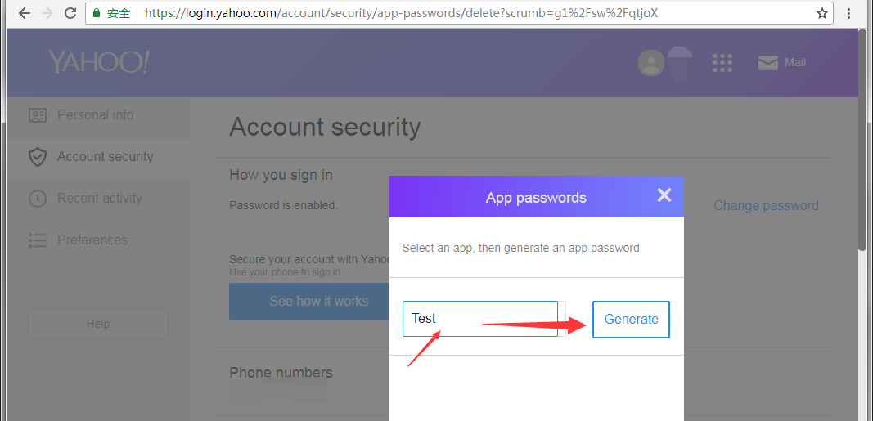
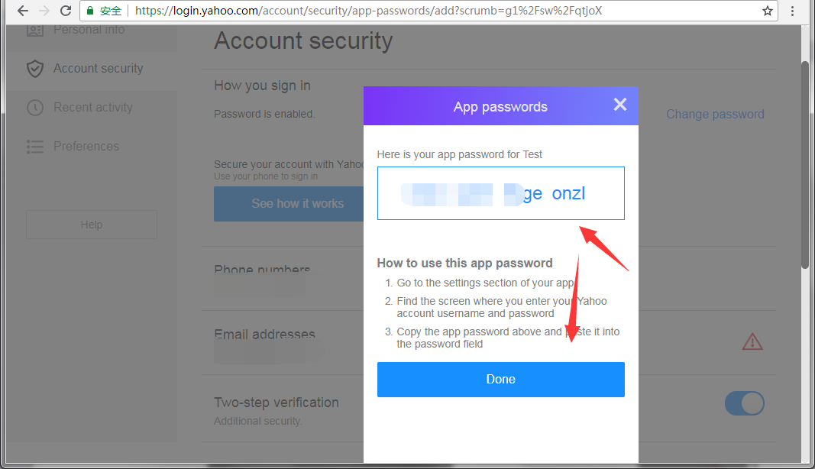

- Outlook
Protocol | Server address | Port | SSL | In CLAD
POP | pop-mail.outlook.com | 995 | Yes | No
IMAP | imap-mail.outlook.com | 993 | Yes | No
SMTP | smtp-mail.outlook.com | 587 | Yes | No

Turn on POP settings
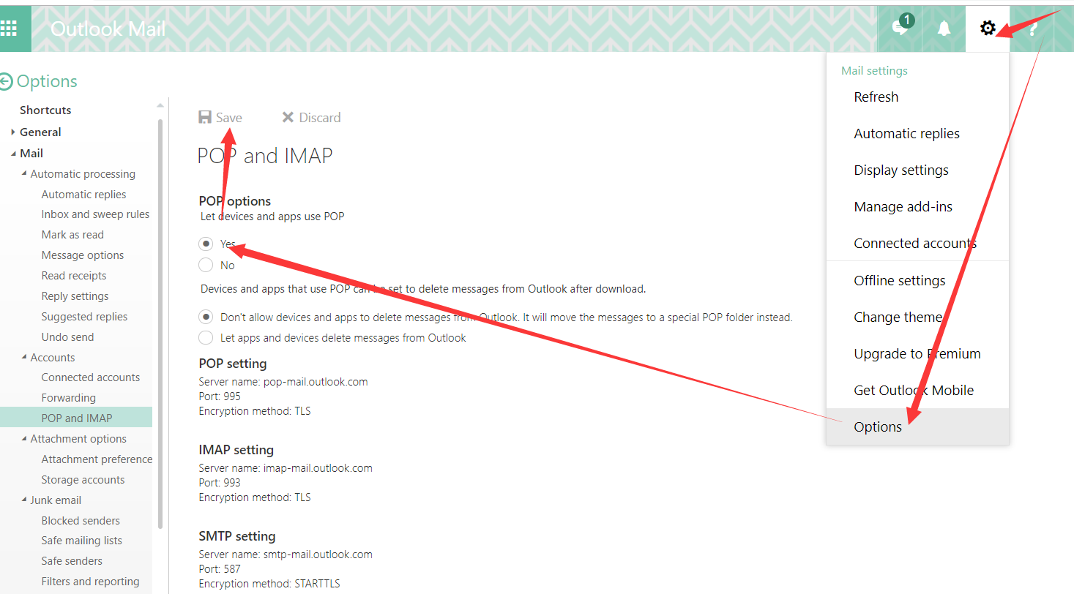
- QQ
Protocol | Server address | port | SSL | In CLAD
POP | pop.qq.com | 995 | Yes | No
IMAP | imap.qq.com | 993 | Yes | No
SMTP | smtp.qq.com | 465 or 587 | Yes | No

Open smtp/imap/pop:
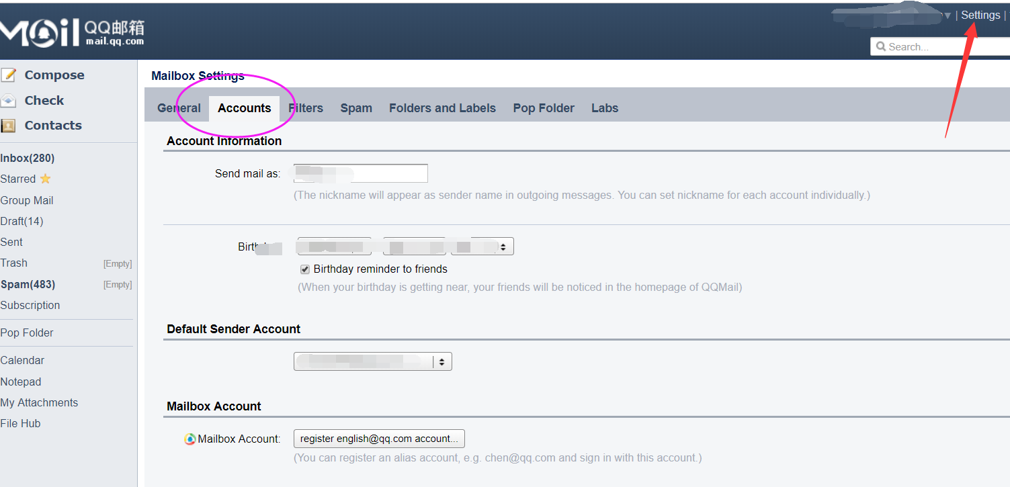
Scroll down to the end of this page, then you can find it.
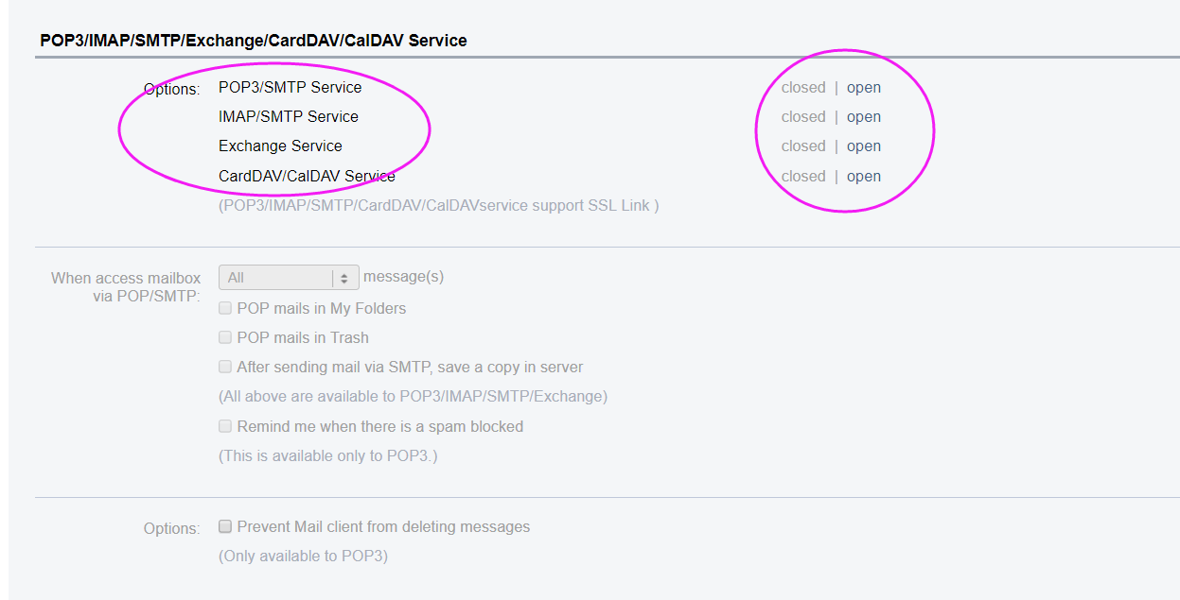

Email type | UserName | Email_password | server | port | Protocol | SSL
Outlook | Your email address | Your outlook password | imap-mail.outlook.com | 993 | IMAP | YES
Gmail | email | Your gmail password | imap.gmail.com | 993 | IMAP | YES
Yahoo | Your email | Your yahoo password | imap.mail.yahoo.com | 993 | IMAP | YES
Mail.com | Your email | Your email password | imap.mail.com | 993 | IMAP | YES
QQ | Your full email address | Your Qq.com password | imap.qq.com | 993 | IMAP | YES
Web.de | Your username | Your Web.de password | imap.web.de | 993 | IMAP | YES
Mail.ru | Your full email address | Your Mail.ru password | Imap.mail.ru | 993 | IMAP | YES

