Manual for Instagram

Click this character “+” to create a task, then just name it:
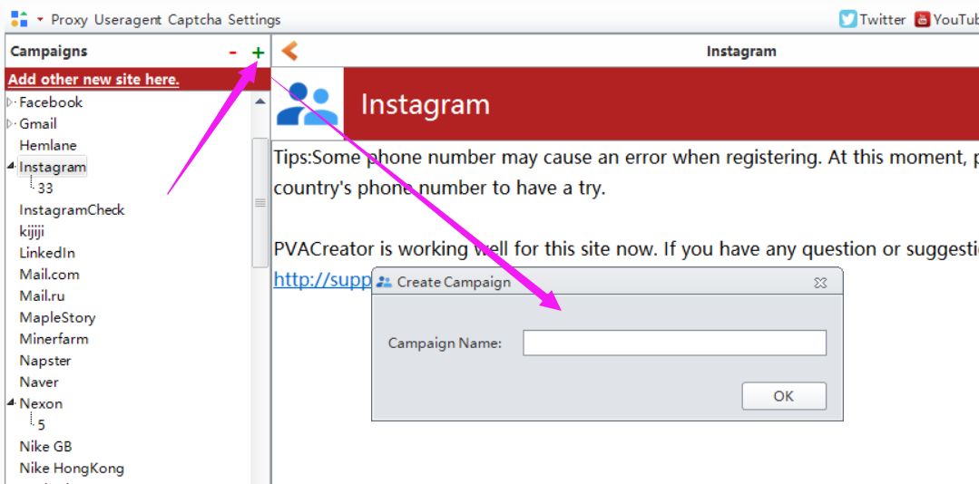

Following are the necessary variables needed to enter data before run：
1, Username
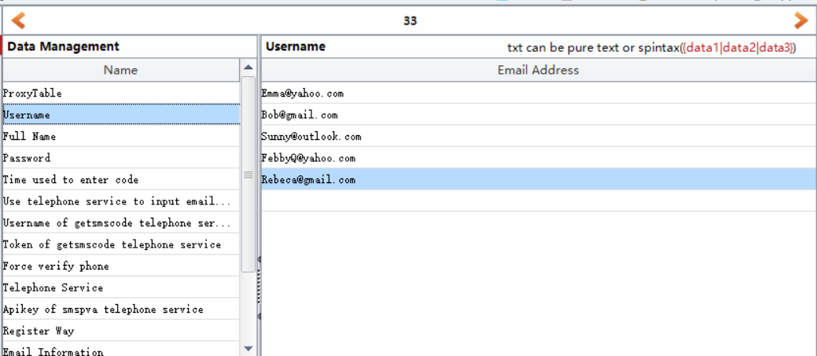
Username is the email address which you will use to register. One email address per column.

2, Use telephone service to input email or phone number
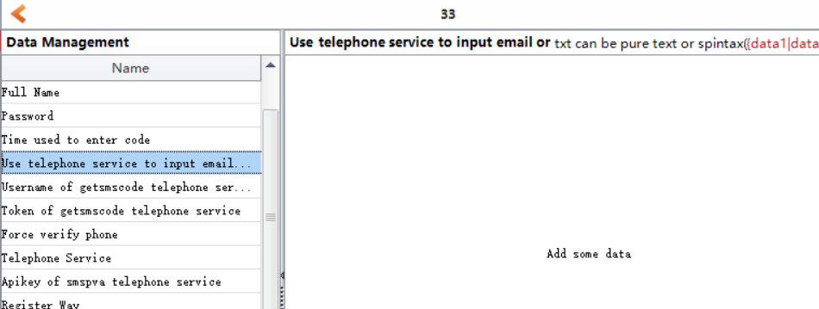
This one is to ask if you want to use phone number to register instead of email address.
- If you want to use phone number to register, then please enter 1 here. Then please choose which phone service you will use in “Telephone Service” option. Here are 2 phone services we are using, and we are using their api. One is getsmscode and the other one is smspva.
- If you enter 1 in “Telephone Service” option , then please register an account in smspva, then charge for your account, then you can find your account apikey in your account profile panel. Then enter it to “Apikey of smspva telephone service” field.
http://smspva.com/
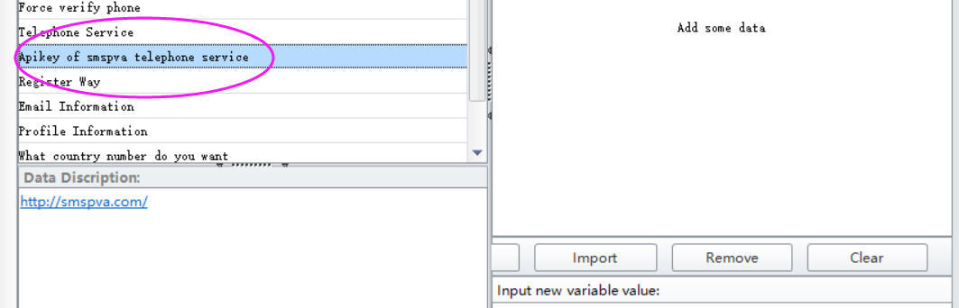
- If you enter 0, then please register an account in getsmscode, then charge for your account, then you can find your account username and token in your account profile panel. Then enter them to “Username of getsmscode telephone service”and ”Token of getsmscode telephone service” fields.
http://getsmscode.com/
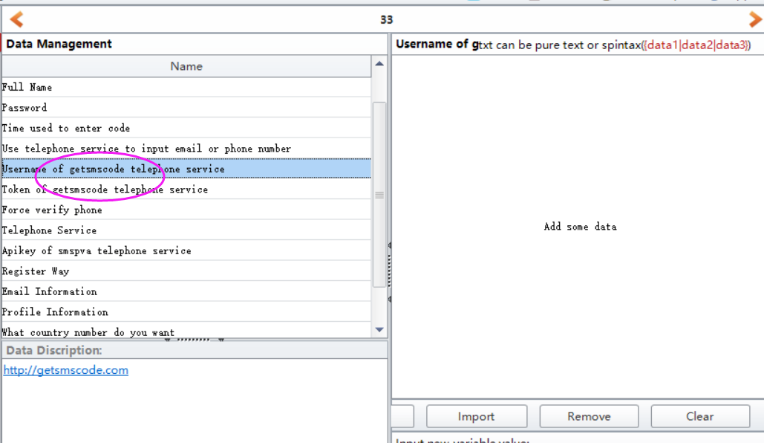
- If you want to use email address to register, then please enter 0 here. Then enter data for “Email Information” option.
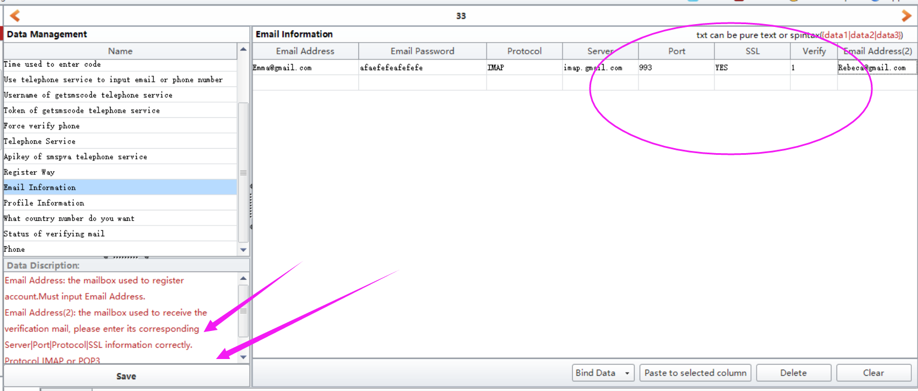
If you are using other domains to register account, and if you do not know where to find the server information, you can Google it, or follow this manual to check if you can find the related information. I will send it this file to you attached with this manual.
Here are two Email Address parameter in this form. This one “Email Address” is used to register Instagram account, and the another one “Email Address (2)” is used to receive and auto verify the verification mail if all of your mails from the 1st registered email address have been forwarded to this account. So “email password”, and these server information (protocol, port, ssl...) is related to this email address (2). Please do not enter the data wrongly.

3, Force verify phone
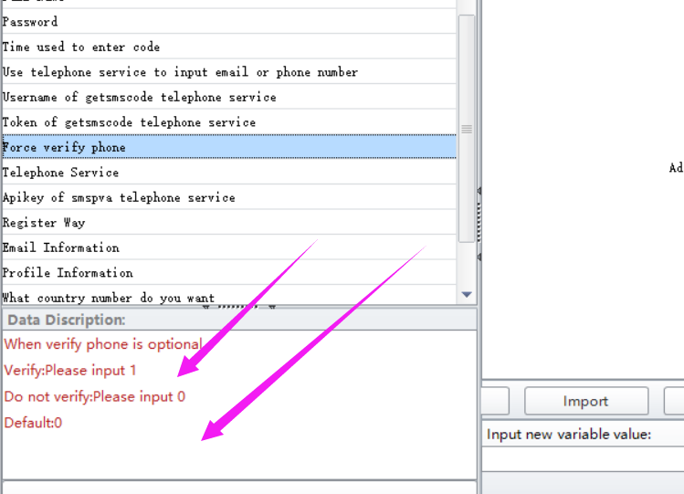
This one is to ask if you want to verify the phone number during register. If yes, then please enter 1, if no, then please enter 0. Default value for this one is 0.

4, Register Way
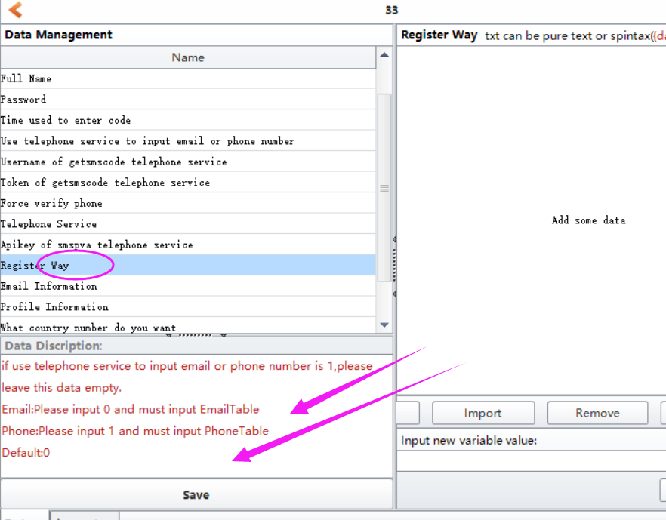
This one is to ask which register method you need.
If you want to register account with phone number instead of email address, then the value for this one can be empty. Also the value for “Email Information” option can be empty too.
If you want to register account with email address instead of phone number, then please enter data for “Email Information” option.

5, Profile Information
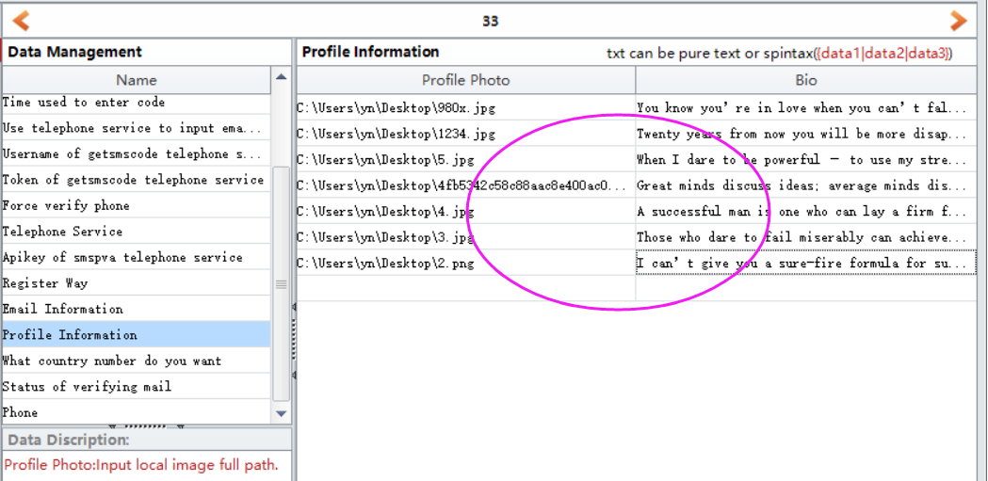
This one is used to update your account avatar and bio. Please pay attention to the avatar file format.

6, What country number do you want
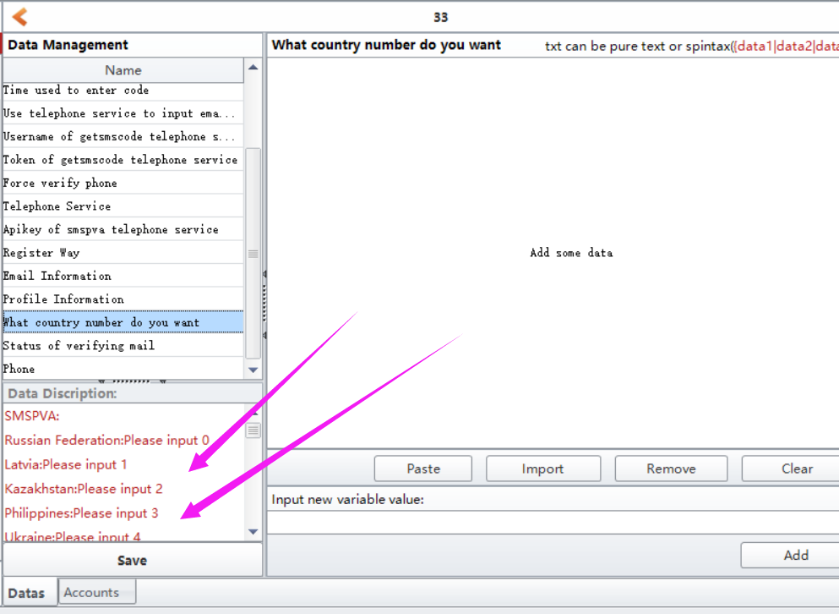
Choose which country phone number you want to use to verify your account.

7, Proxy Manage
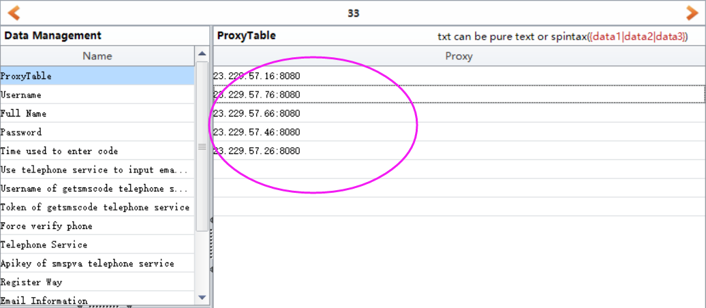
If you do have proxies and wish to create many accounts, then please enter your proxies in this filed. Please use HTTP proxy.
Proxy format can be: ip:port or ip:port:username:password
Eg: 23.219.57.96:8080 or 23.219.57.96:8080:proxy username:proxy password

8, Save
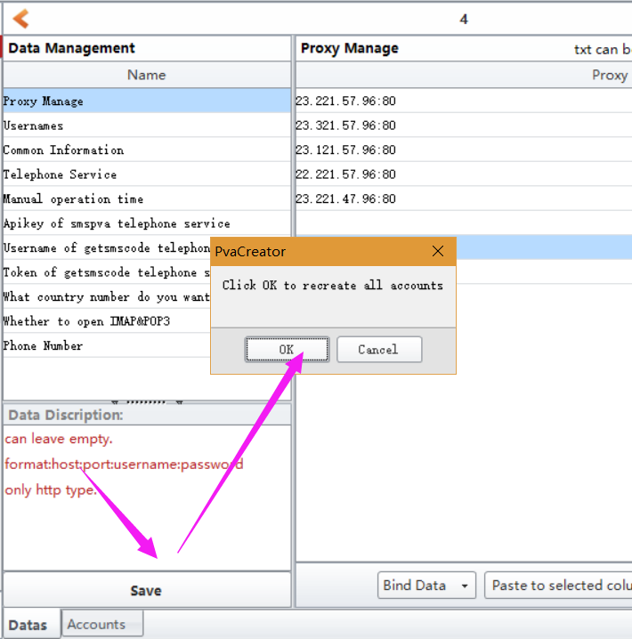
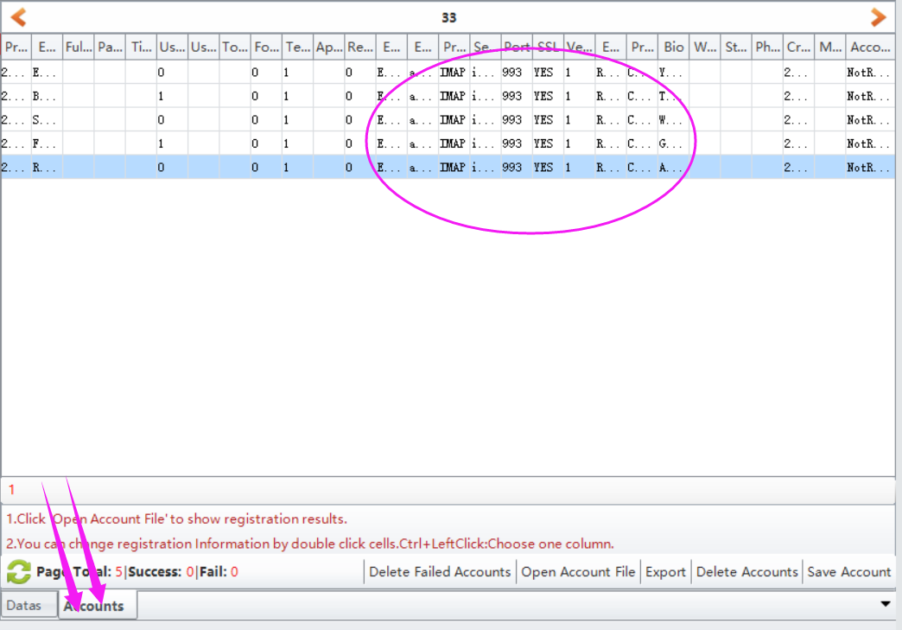

7, click Start button to start to run.
When it starts to run, here will be a debug window open, and you can view the whole running process.
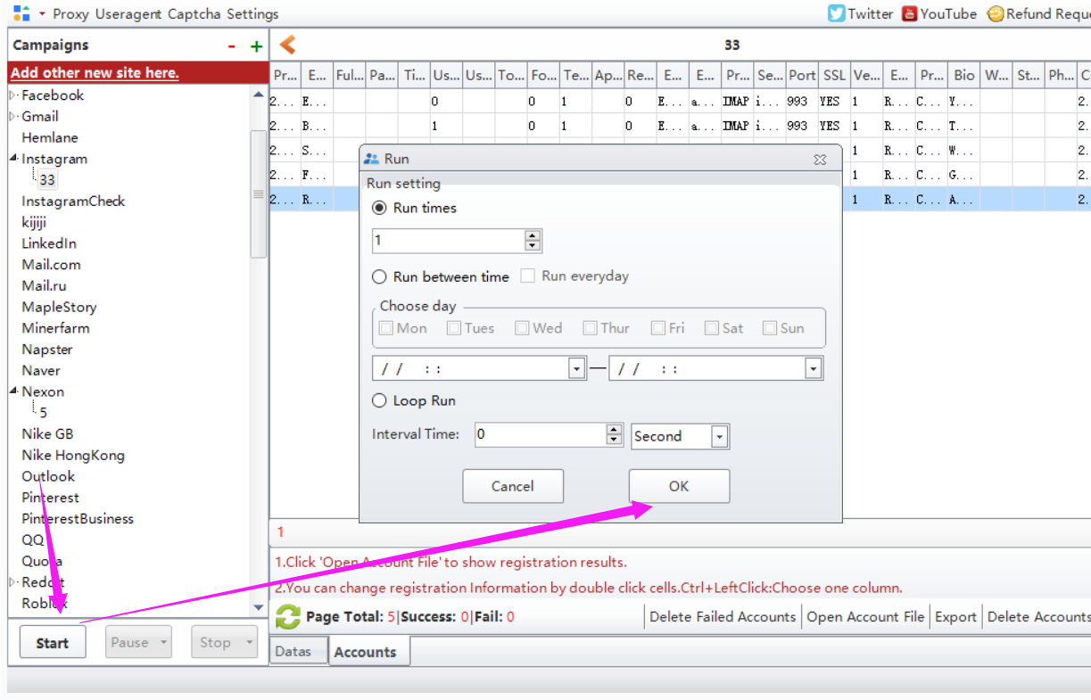

Options under “Bind Data”:
Import from file: import the data from your local prepared file at a time. Note: please choose the column first where you need to upload the data to.
UseRandom: custom some letters, numbers to auto generate data for these information. Such as full name, age, password. Note: please choose the column first where you need to custom and auto generate data.
Eg: if the first character is Funny, i will auto generate 1-4 number behind it. The first picture is the settings, the second one is the result it generates.
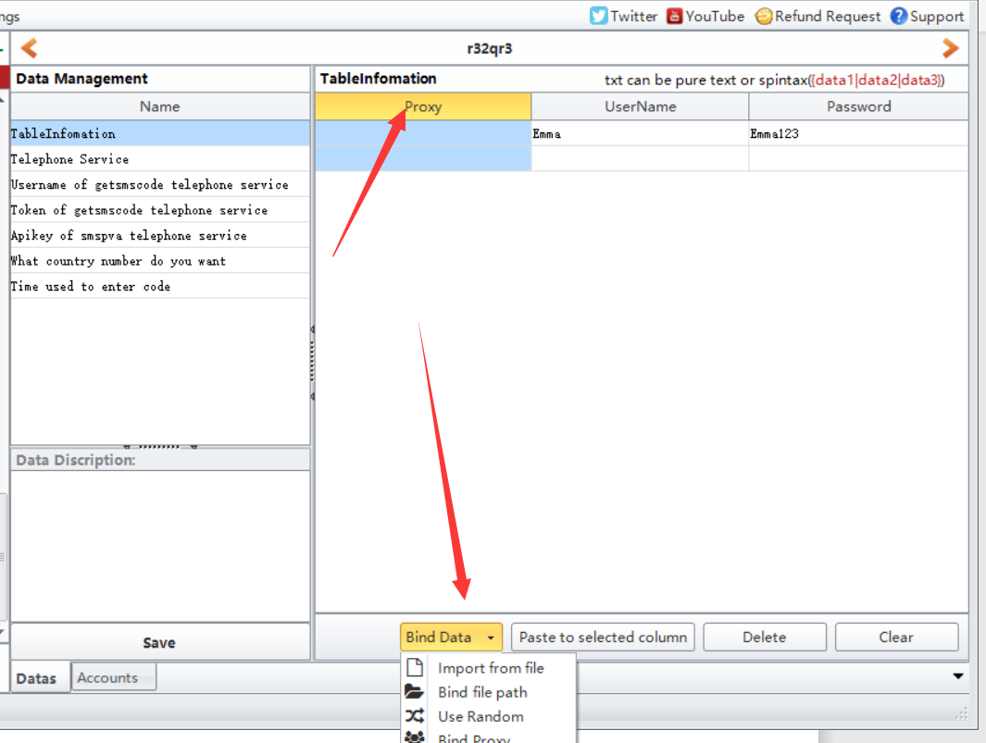
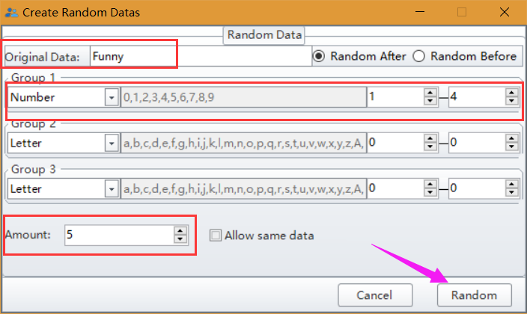
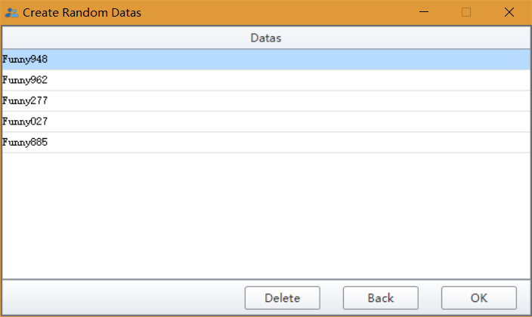
Bind Proxy/Useragent: bind proxy/useragents to these data at a time.

